**Name: Tasmia Shafi**

**ID: MCSF19M039**

Practice: Lecture 2

Date: 17 Feb-2021

Introduction To VCS and GitHub Basic Commands

**STEP 1:**

**Create New Repository:**

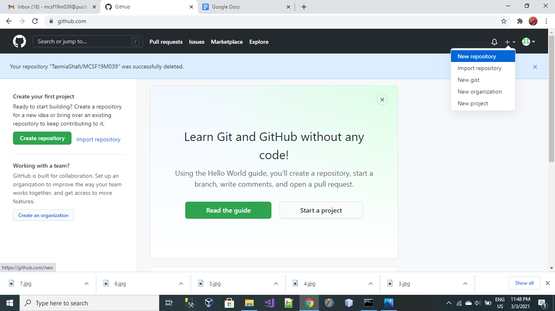

**STEP 2:**

**Assign a valid name to your Repository:**

Give a valid name to your Repository, as I mentioned **MCSF19M039** in the following picture.

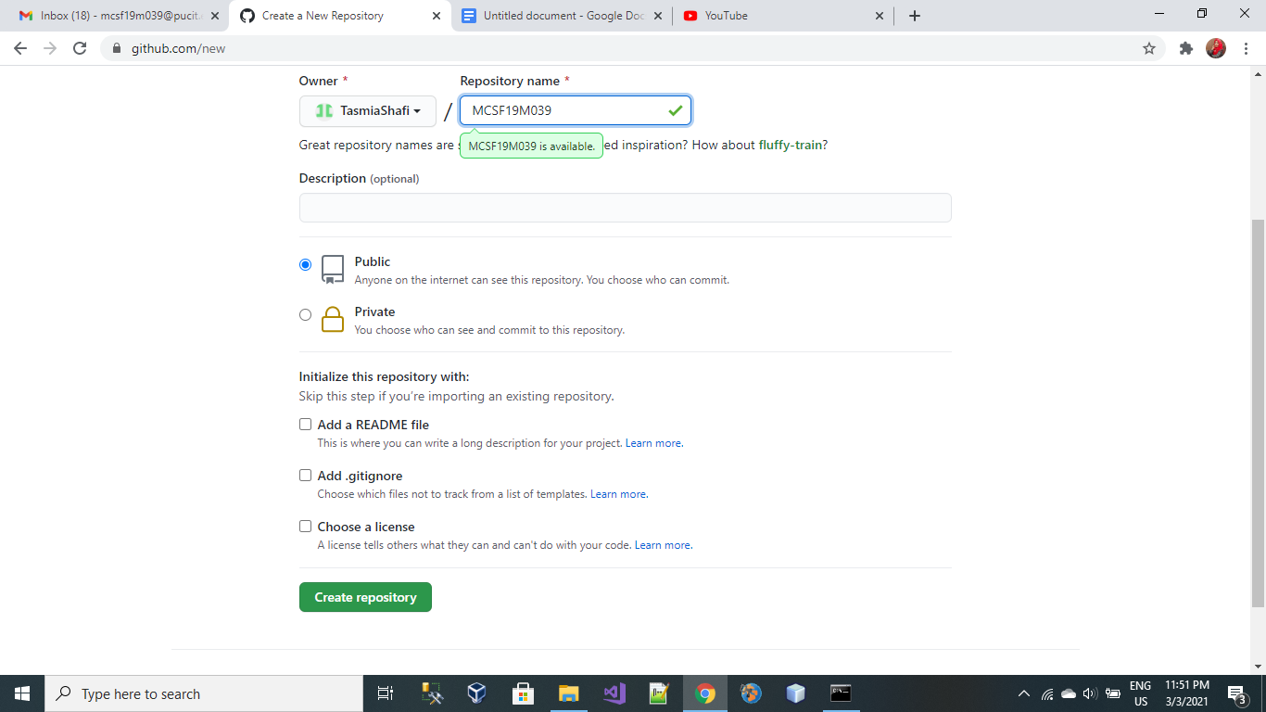

**STEP 3:**

**Create a Clone Repository on your Local Device:**

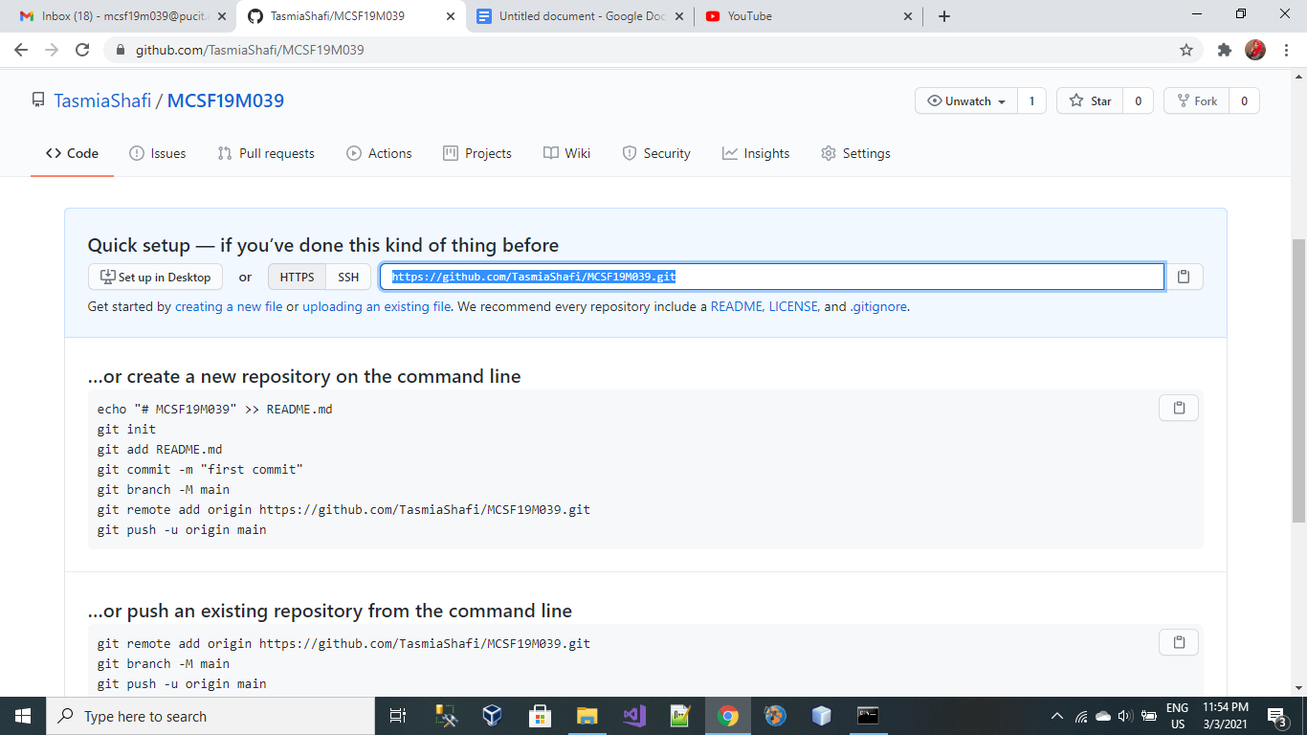

Copy the Repository URL as mentioned above and paste it incommand Promptand type:

**git clone url**

git clone [**https://github.com/TasmiaShafi/MCSF19M039.git**](https://github.com/TasmiaShafi/MCSF19M039.git)

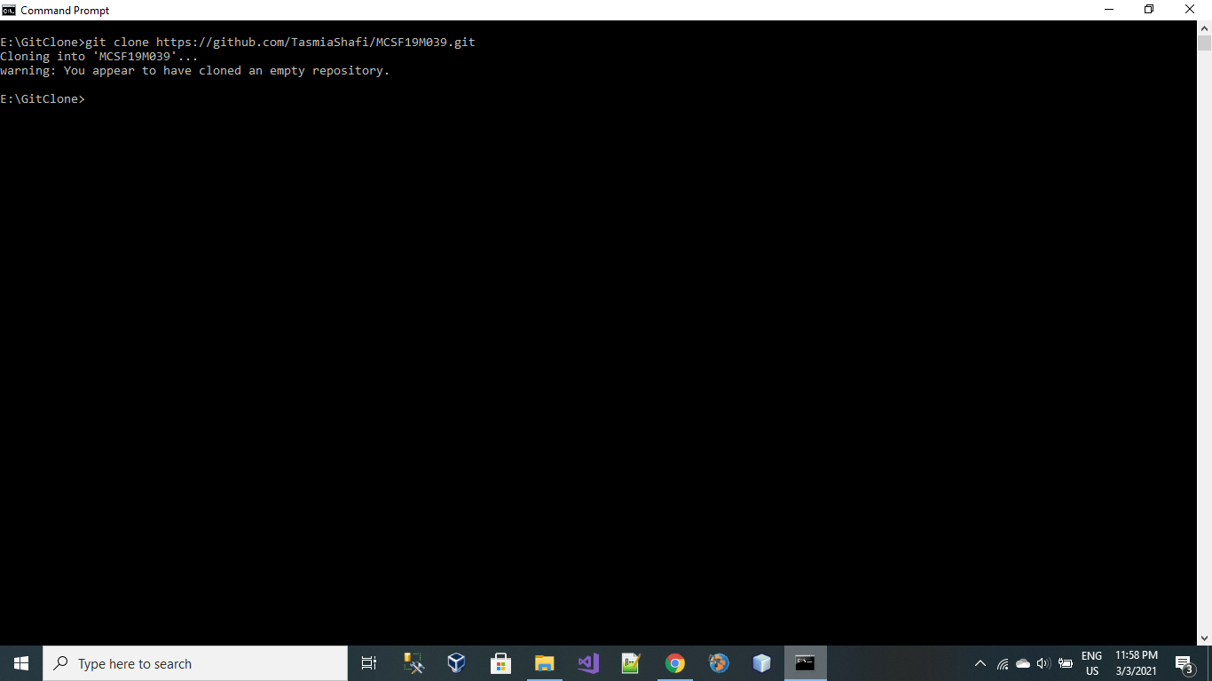

**Clone has been Created!!**

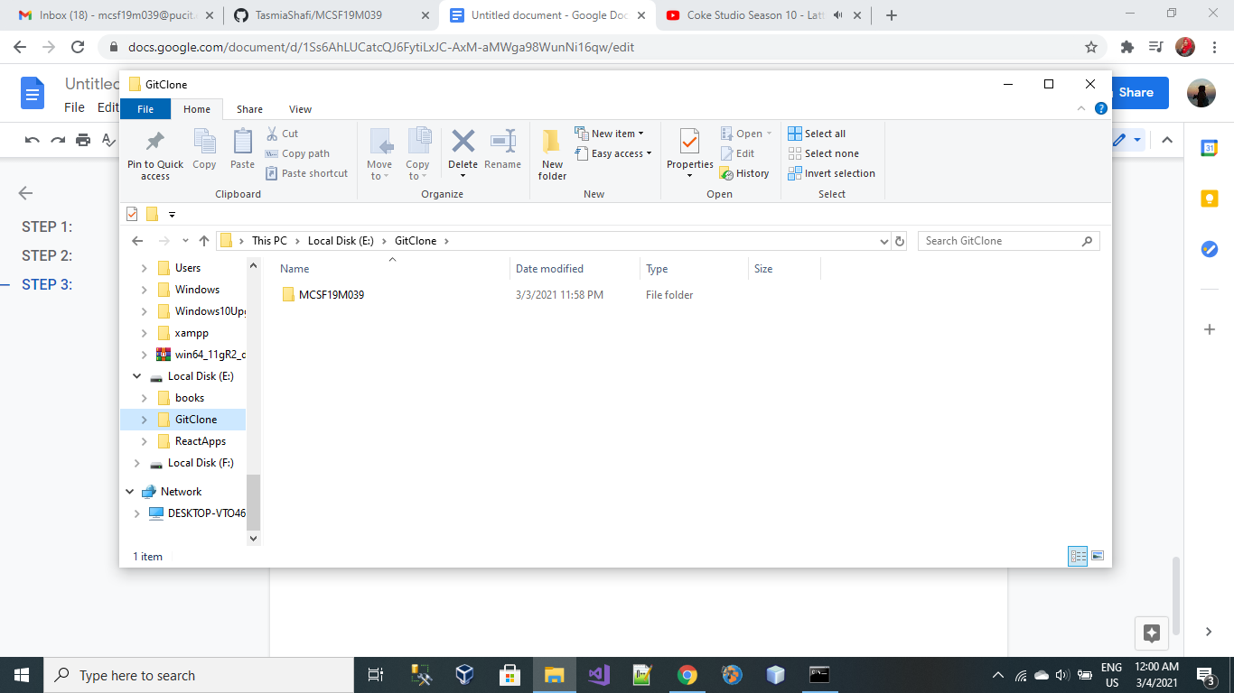

**Step 4:**

**Add files/folders on remote server (Github Repository)**

Upload your local files and folders to github repository by typing following command:

**git add “filename”**

git add “CSS_classes.html”

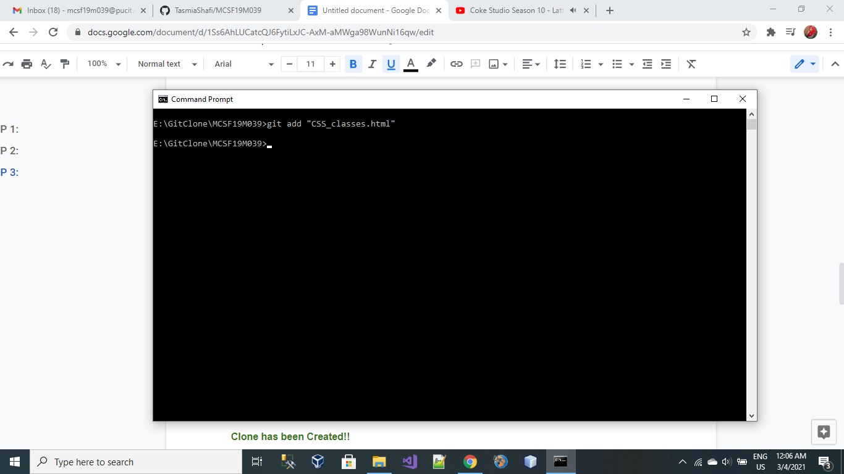

**STEP 5:**

**Commit Command:**

**git commit -m “message”**

git commit -m “CSS file uploaded”

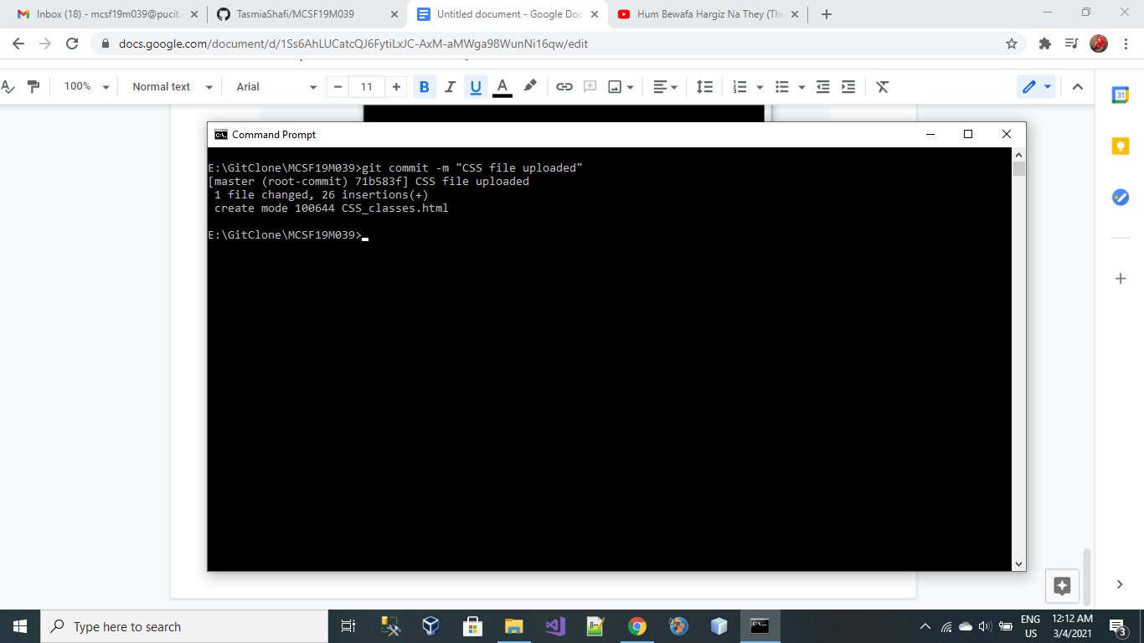

**STEP 6:**

**Push Command:**

**git push**

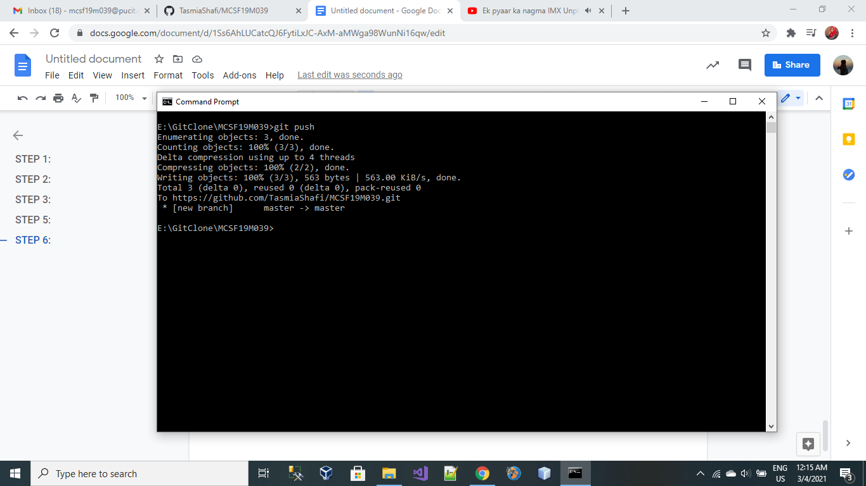

**WOW!! Finally my first file has been pushed to GitHub repository**

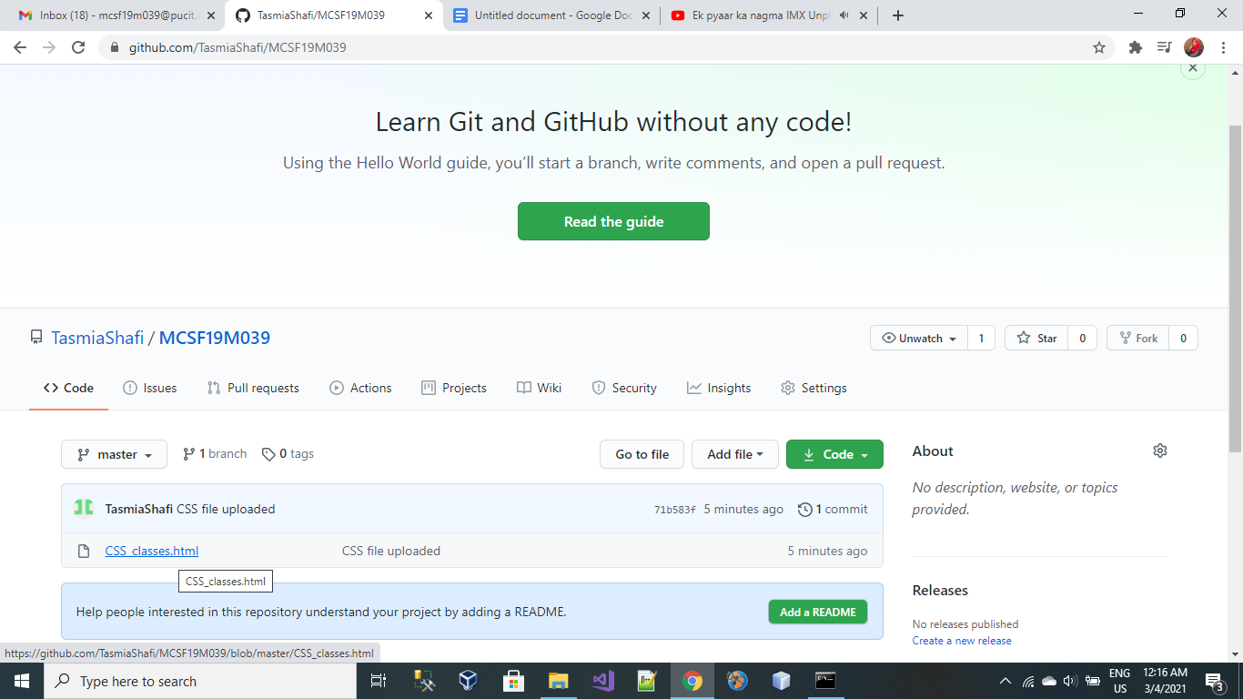

**Lecture 3**

**Date: 1st March 2021**

**git pull Command:**

**File in my Local Repository:**

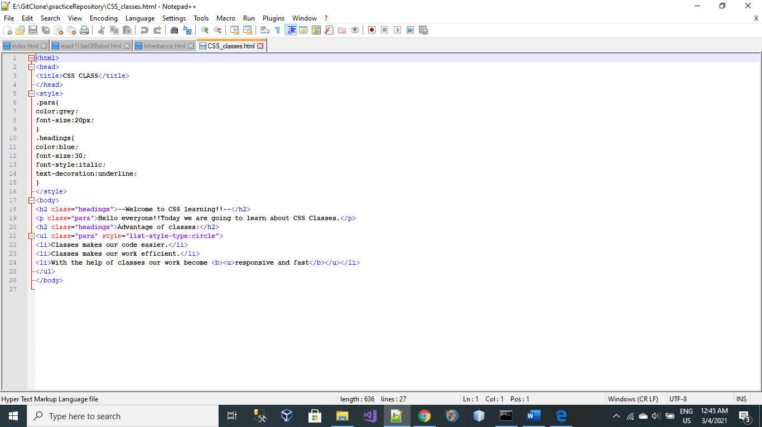

**File in my Remote Server:**

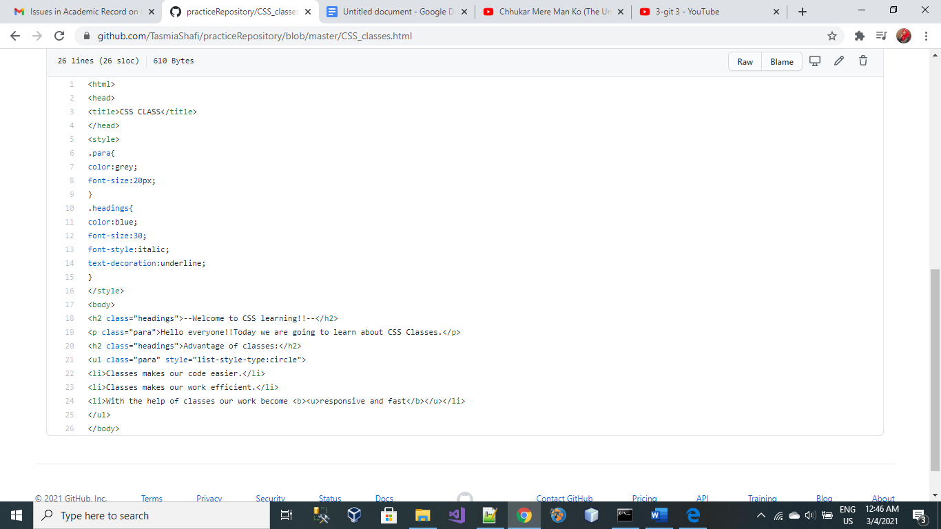

**OUTPUT:**

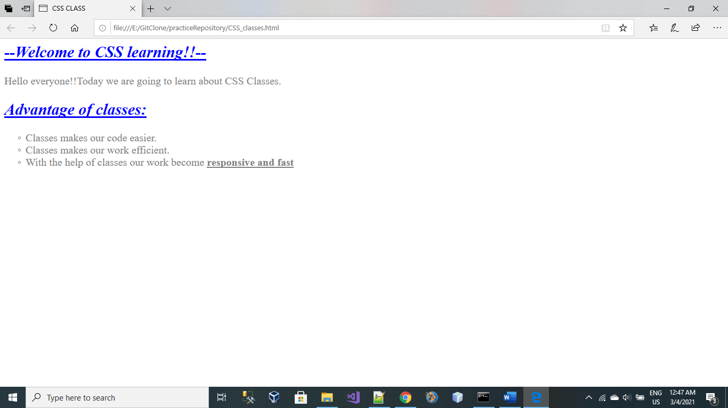

**Change File in your System:**

**STEP 1:**

Open the file in Notepad++ or any other Editor and make changes in your File.

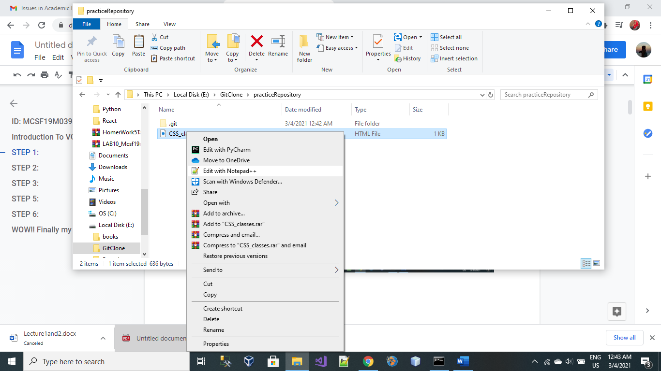

**After Making Changes In File On My System:**

I have changed the headings Color from **Blue to Red.**

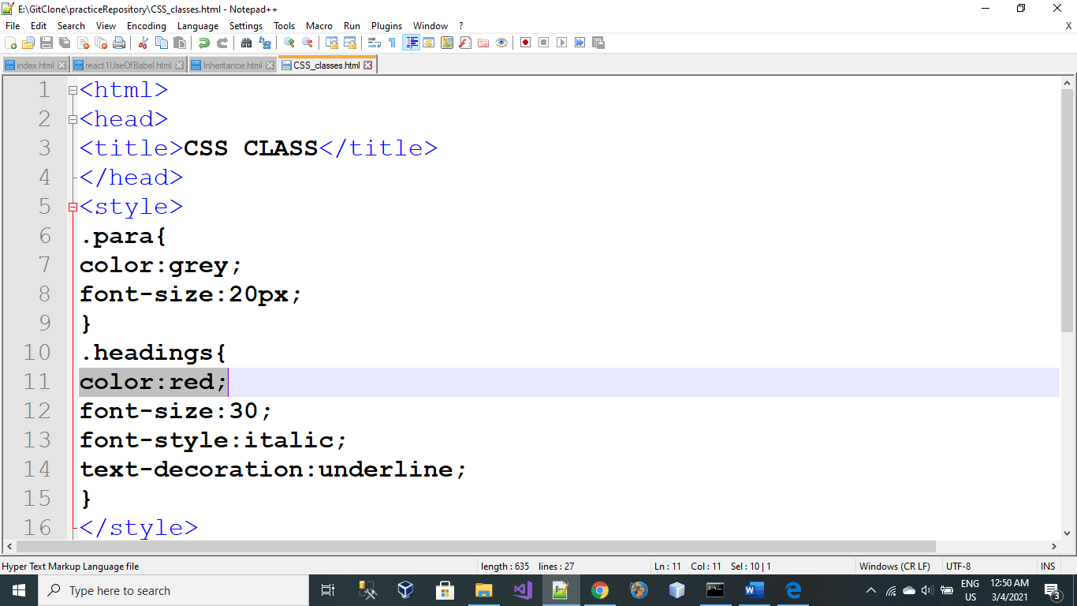

**Note:**

Now if you want to apply changes in your online GitHub repository. You should repeat all those three steps which we learn in our last lecture:

1. git add
2. git commit -m “message”
3. git push

Yeah my File has been Changed as Expected!!

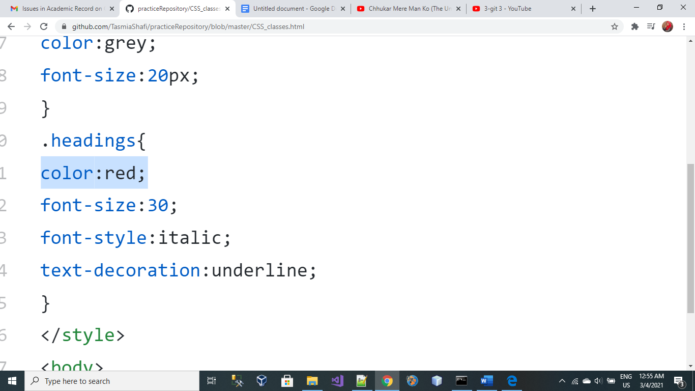

**OUTPUT:**

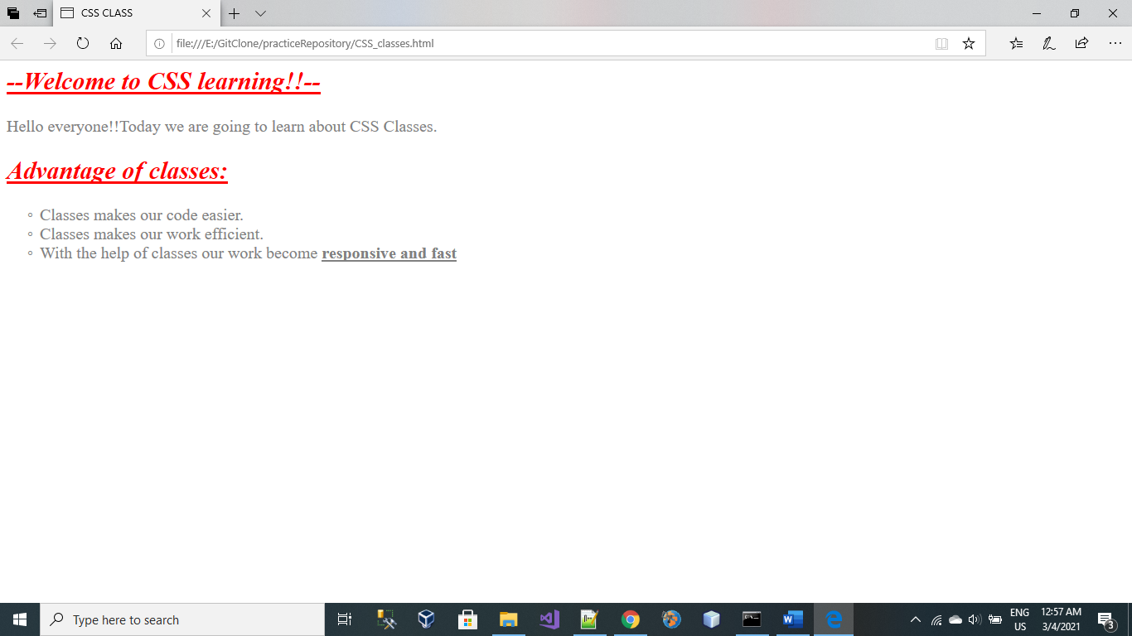

**Online Editing Your File:**

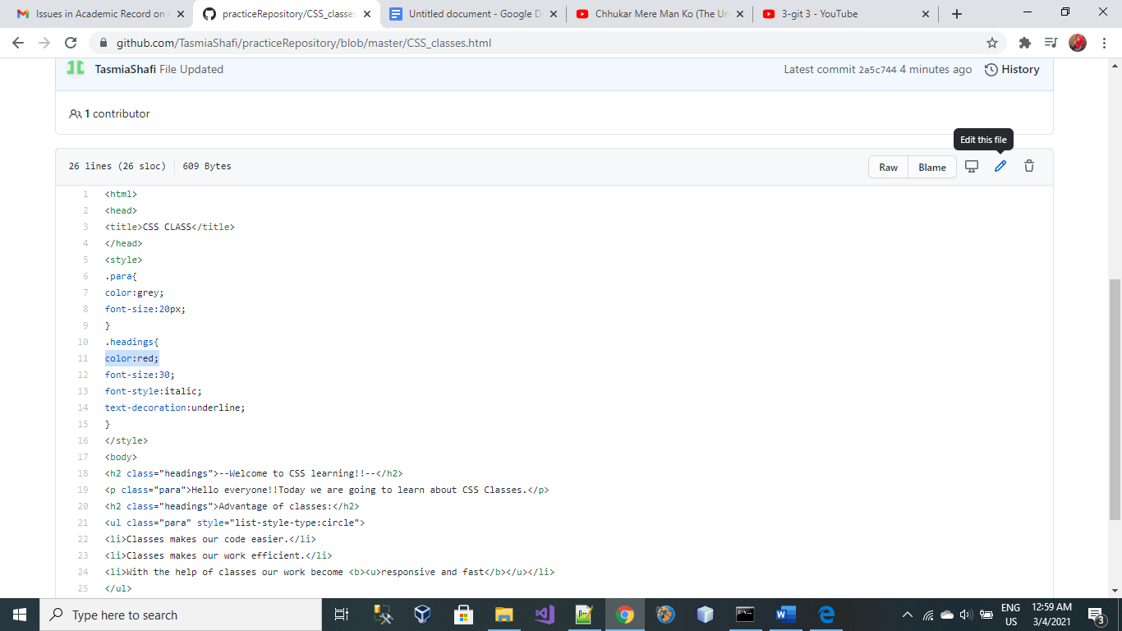

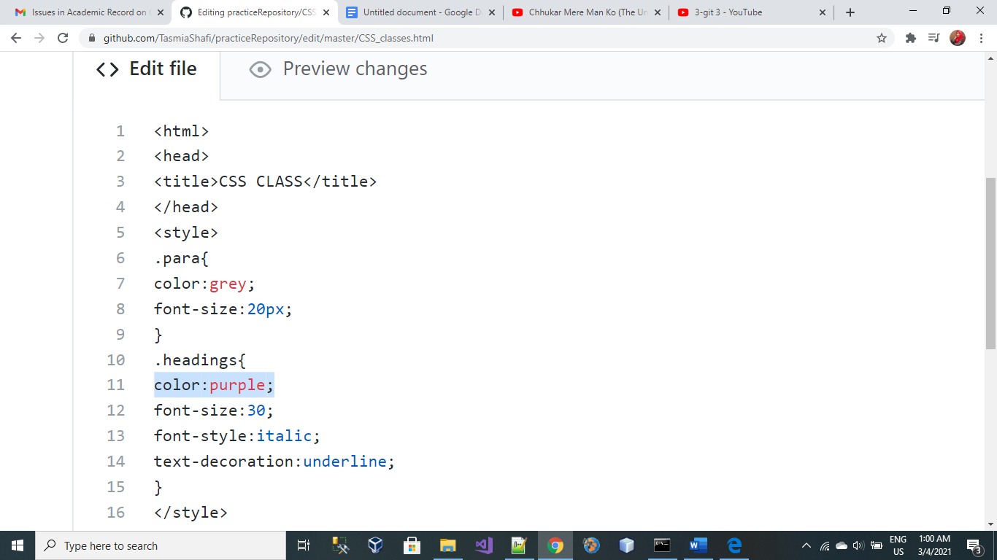

**Add Commit:**

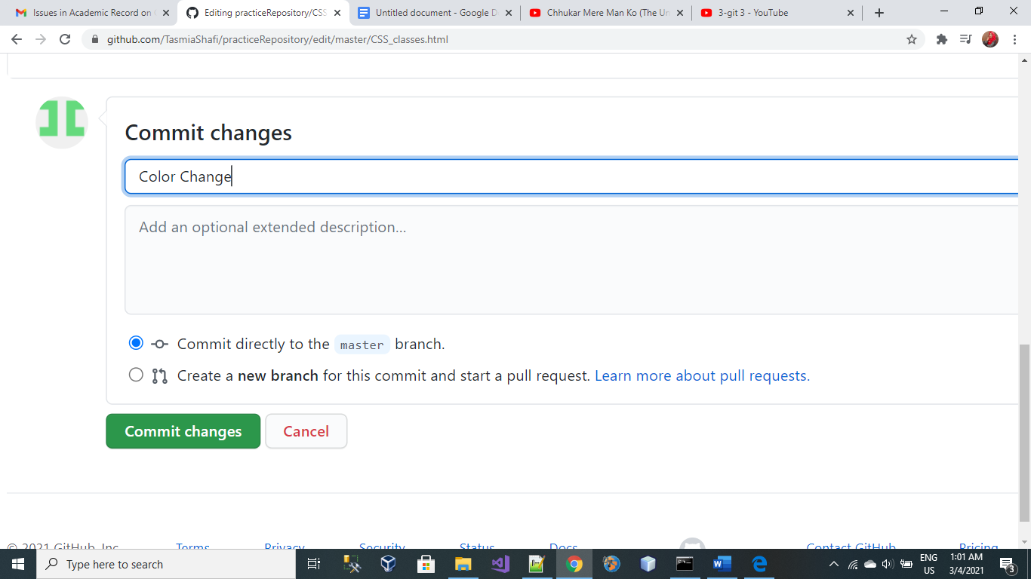

**Note:**

File has been updated online but not in your local computer as you can see below.

Online File:

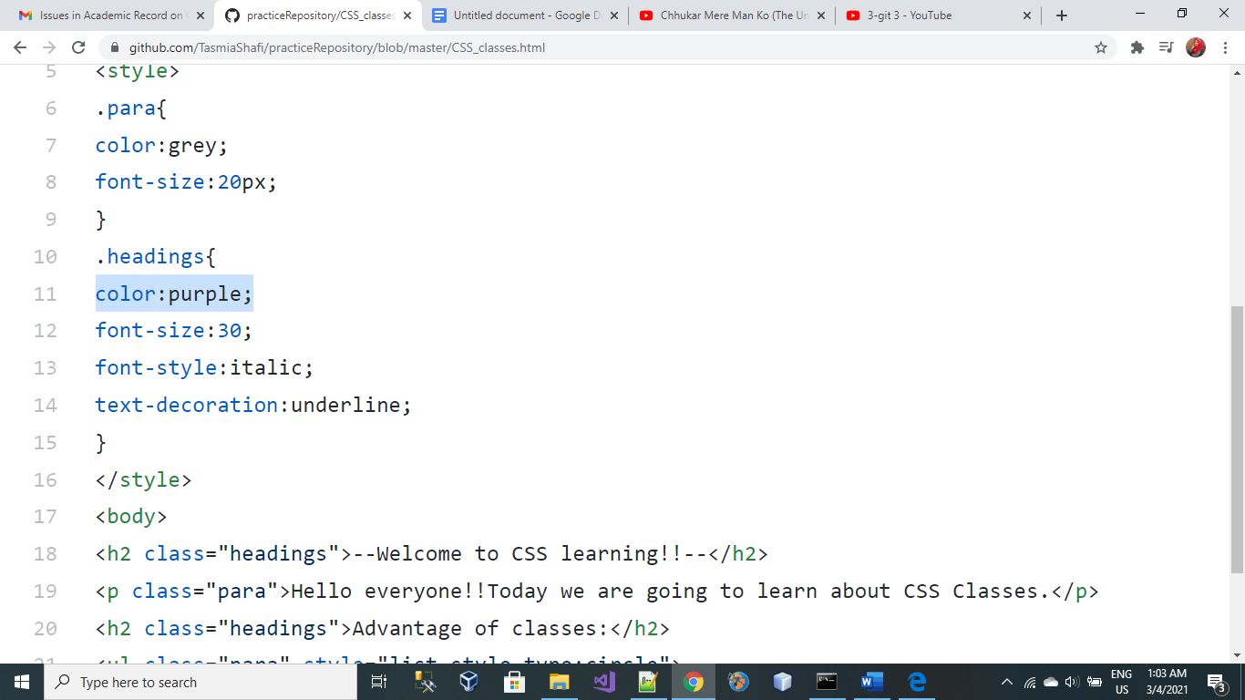

Local Computer File:

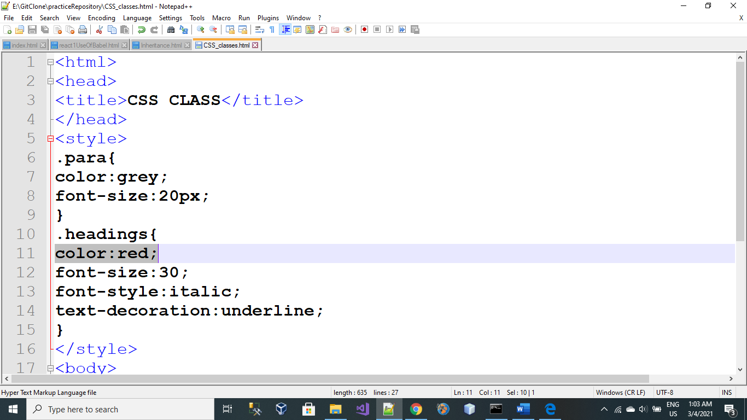

Note:

To show changes in your local repository as well. So, you’ve to **pull data** from an online repository.

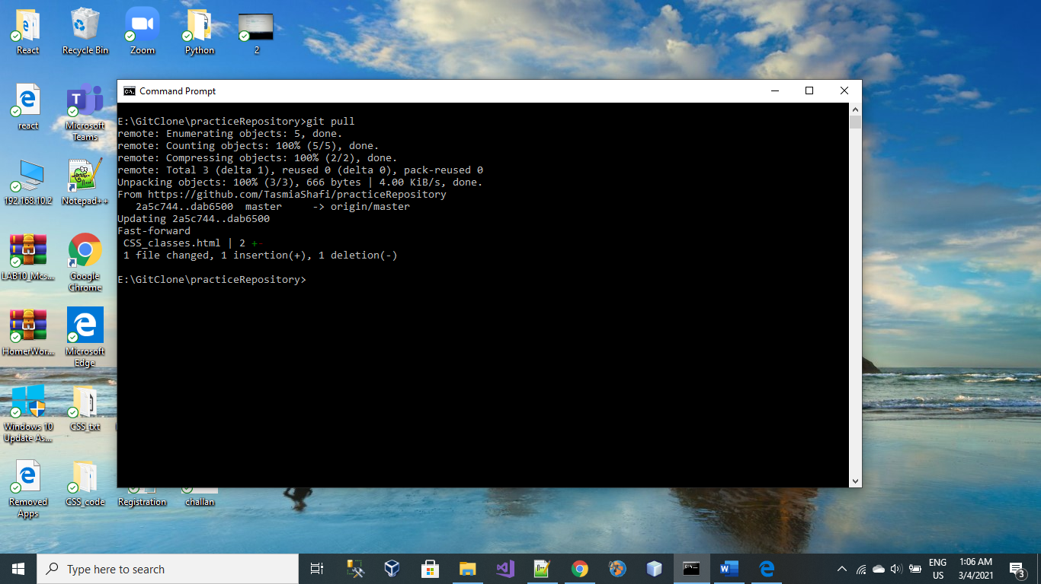

**Updated File in Local Repository:**

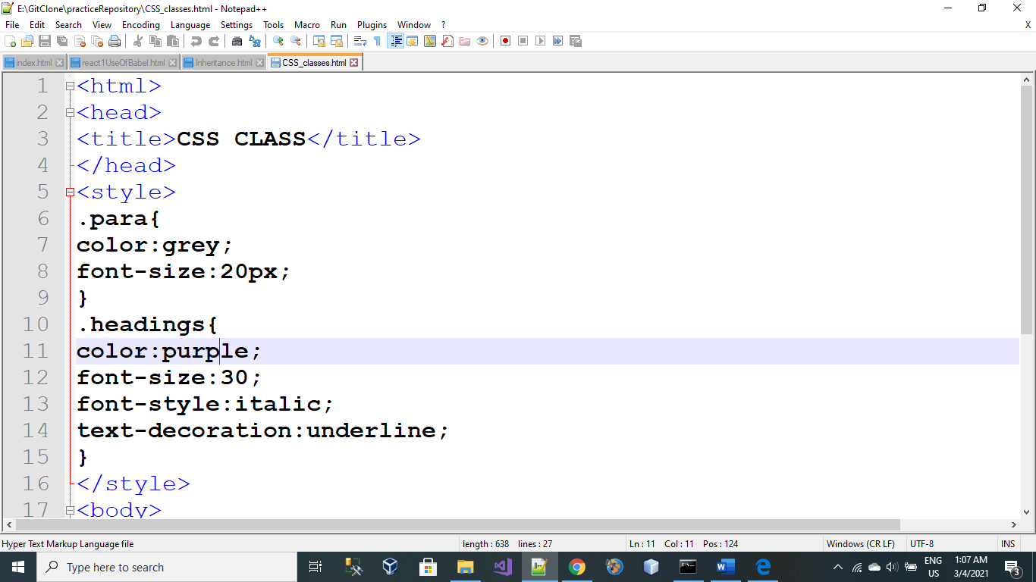

**OUTPUT:**

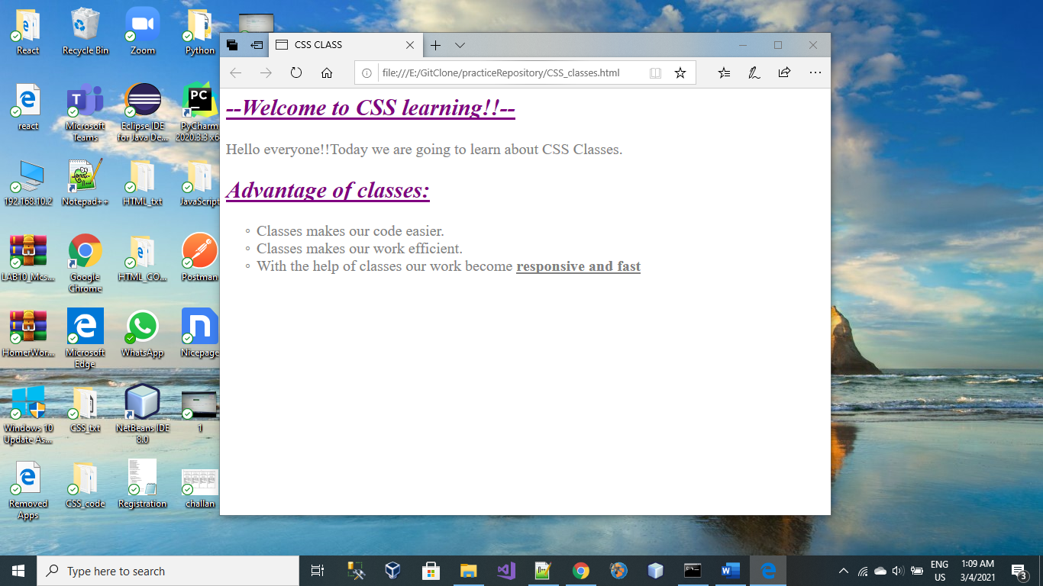

**Merge Conflict:**

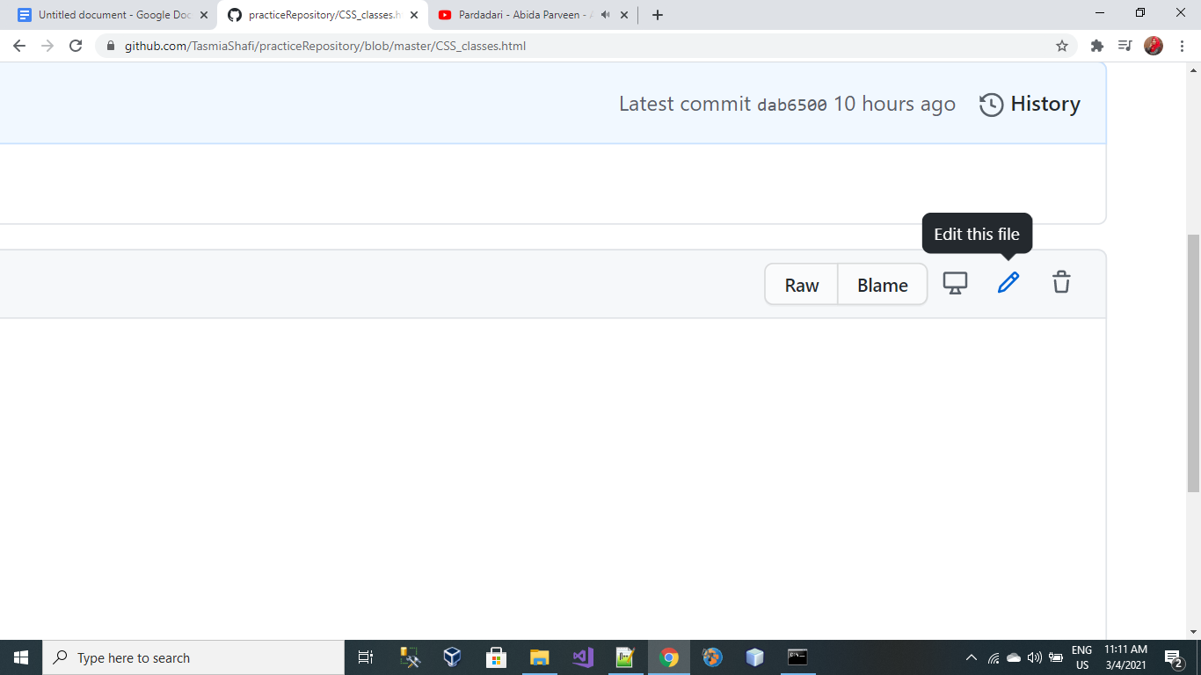

File edited remote repository.

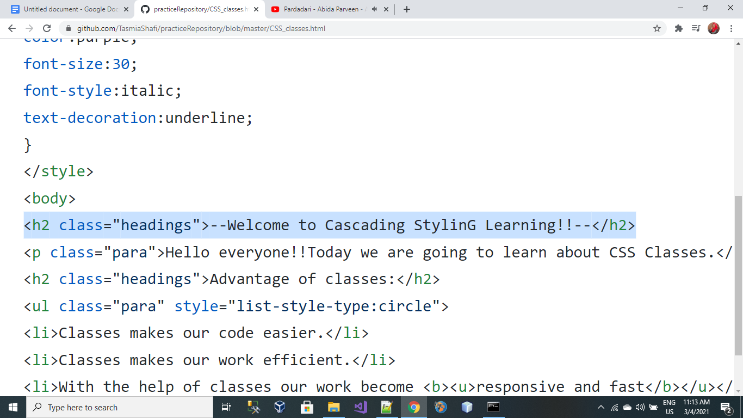

At the same time I edited my file in my local repository.

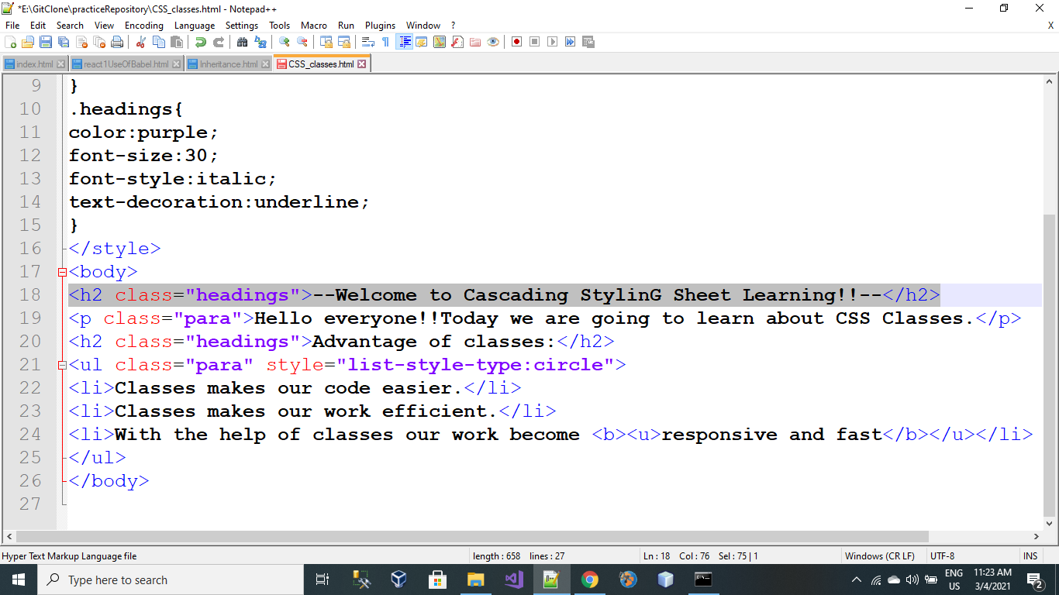

After changing file at same time in both repository then “merge conflict” error occurred.

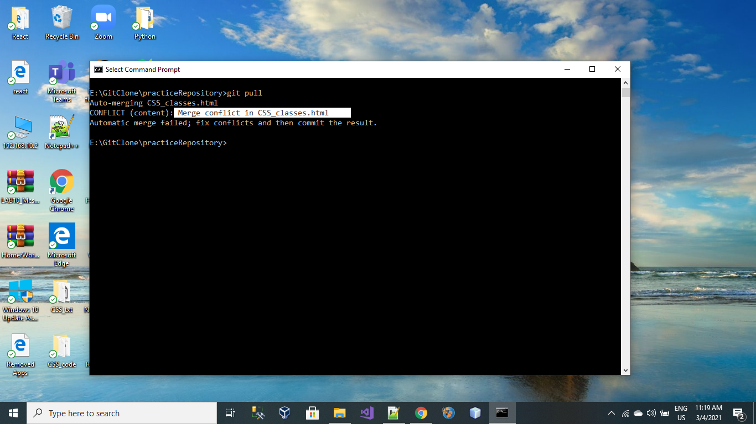

And my file in local Repository looks like this. Then remove all unnecessary changes and and push file in your remote repository.

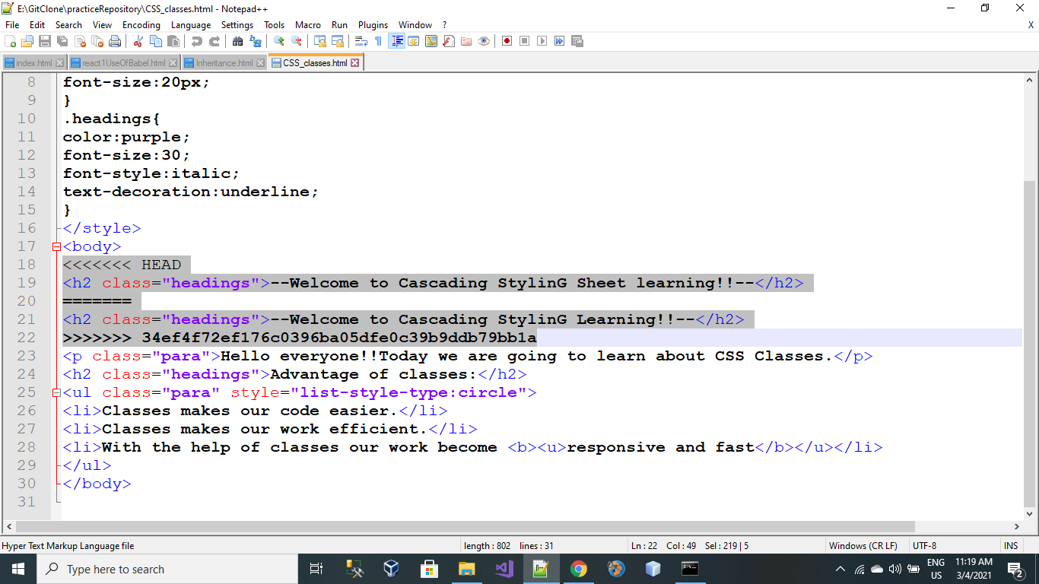

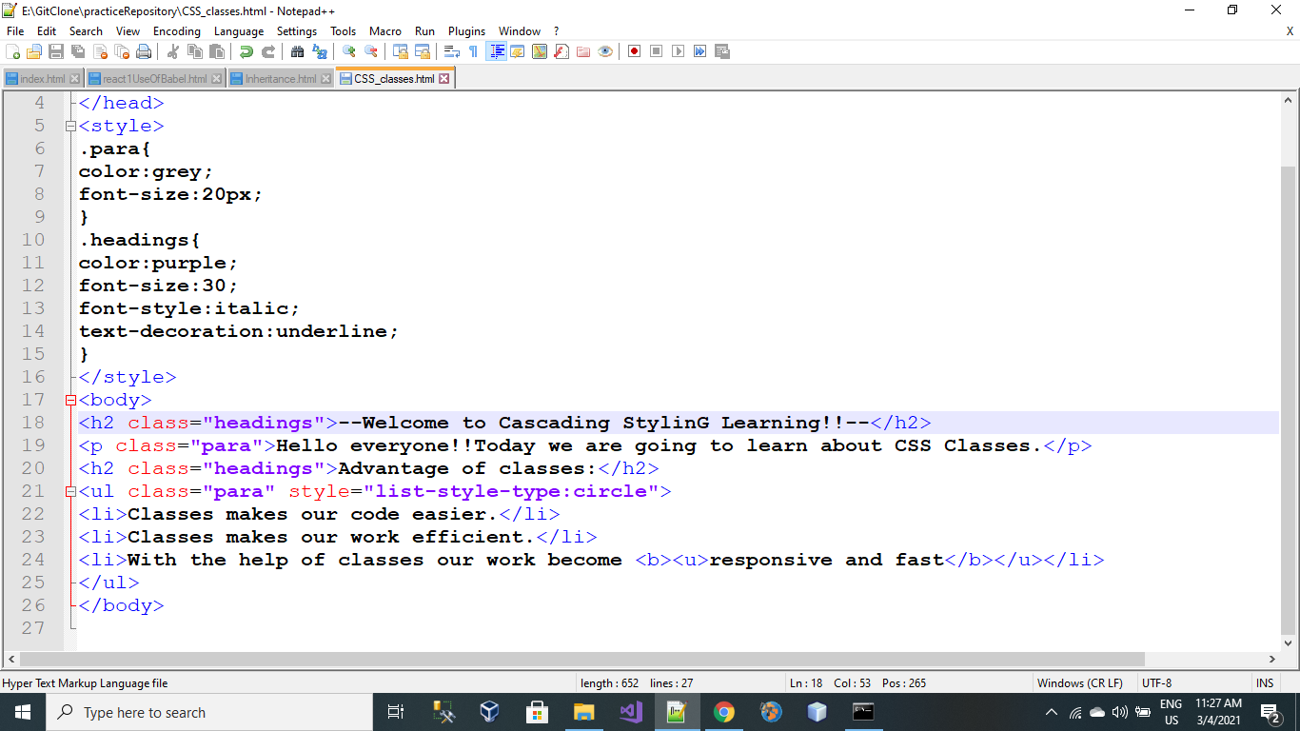

**Yeah Merge Conflict Problem Solved!!**

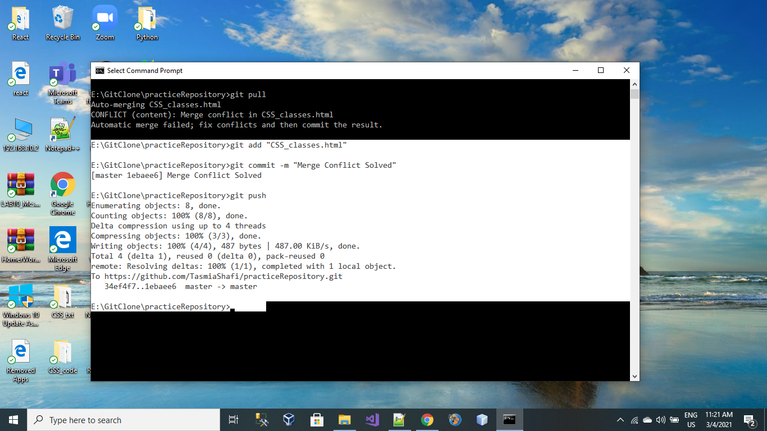

**GitHub Repository File:**

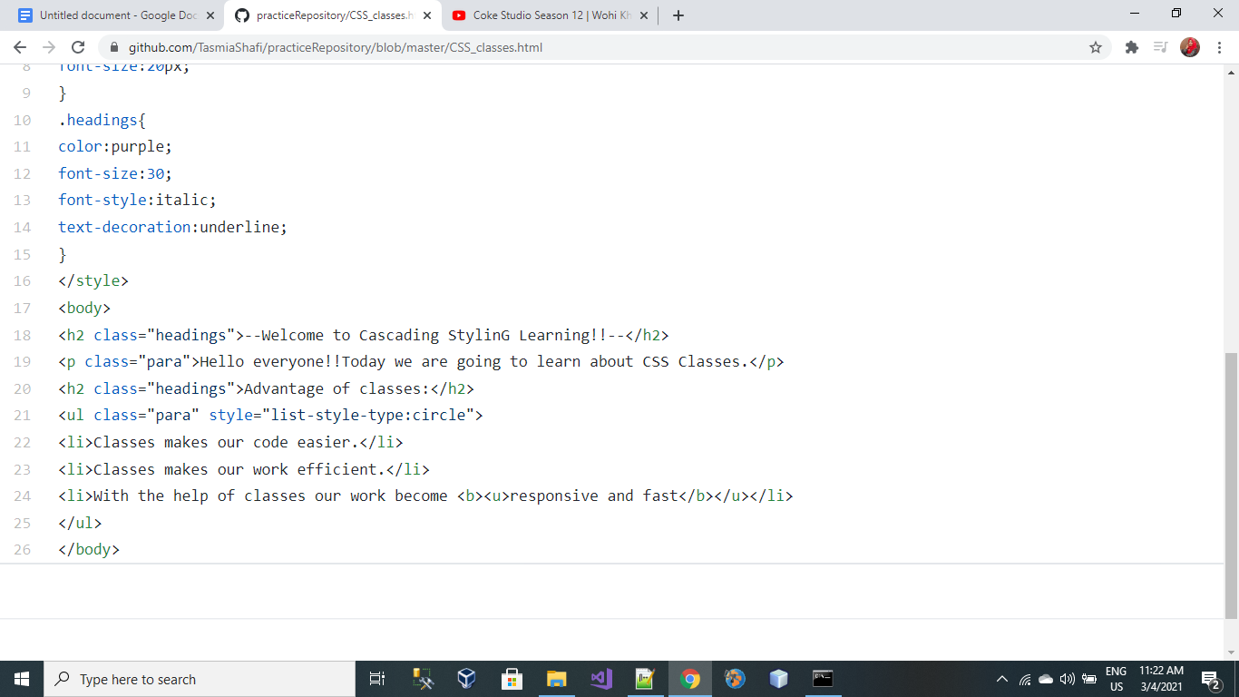

**Git log Command:**

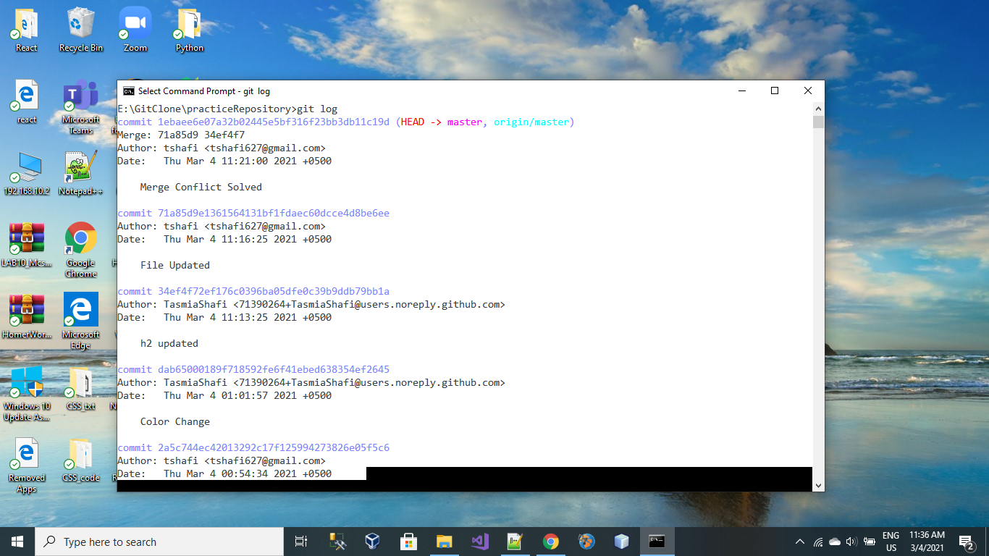

**Git branch Command:**

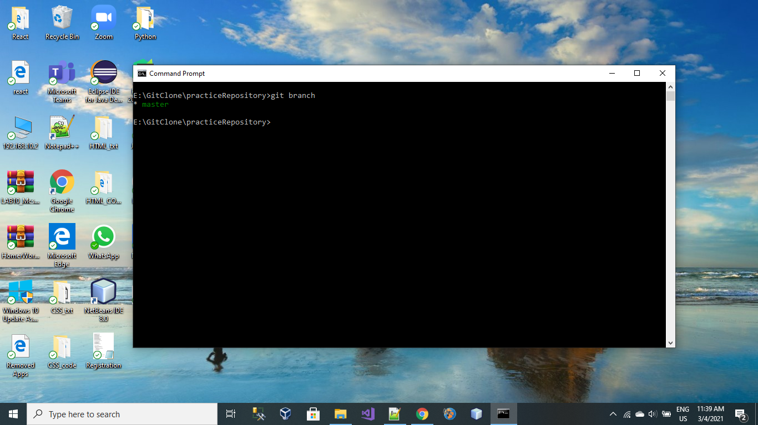

**How to Create a new branch:**

To create new branch in GitHub Repository:

**git branch “branch Name”**

git branch “branch 2”

**New branch has been created, as shown in following screenshot.**

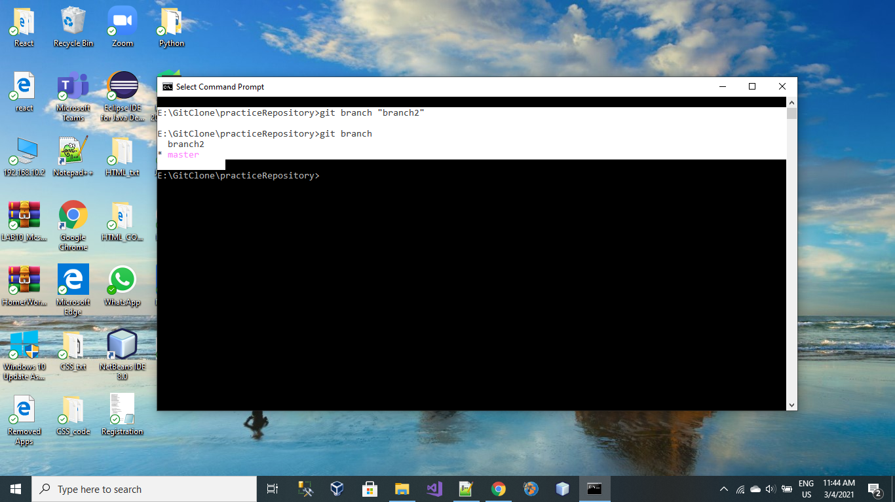

**Switching From 1 branch to another Barnch:**

Current branch which is active and my head is pointing to **“master branch”** as shown in following screenshot.

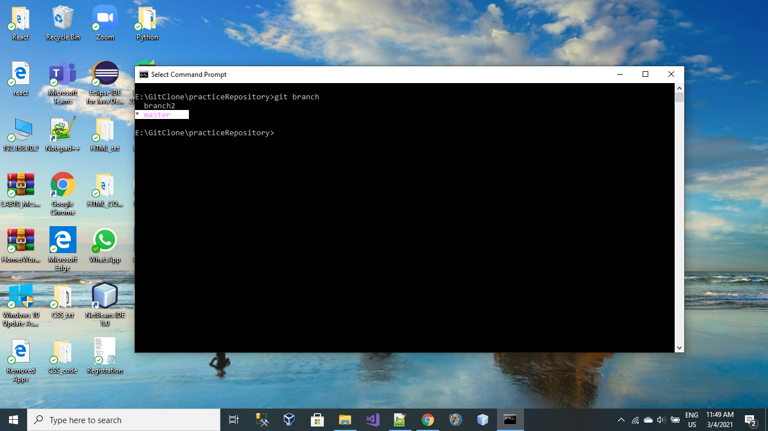

**Switch to “branch 2”:**

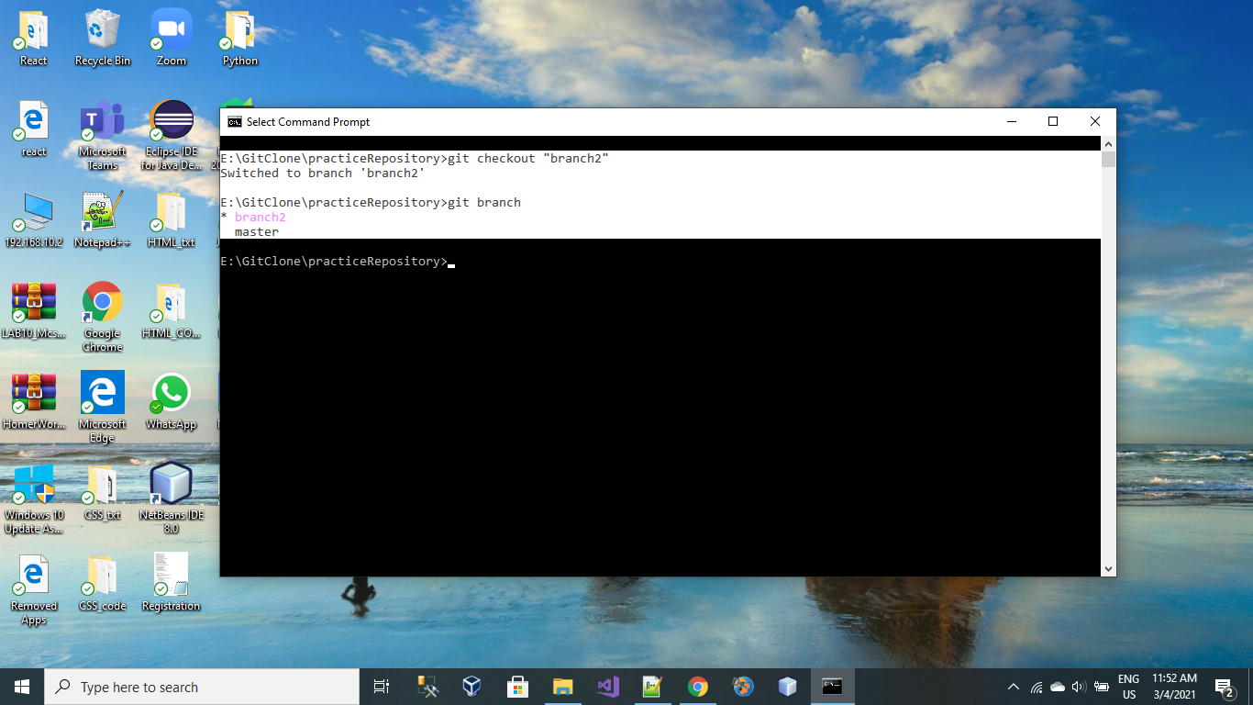

**Add File In Branch 2:**

All procedure of pushing data into new branch is same as previous except the following step:

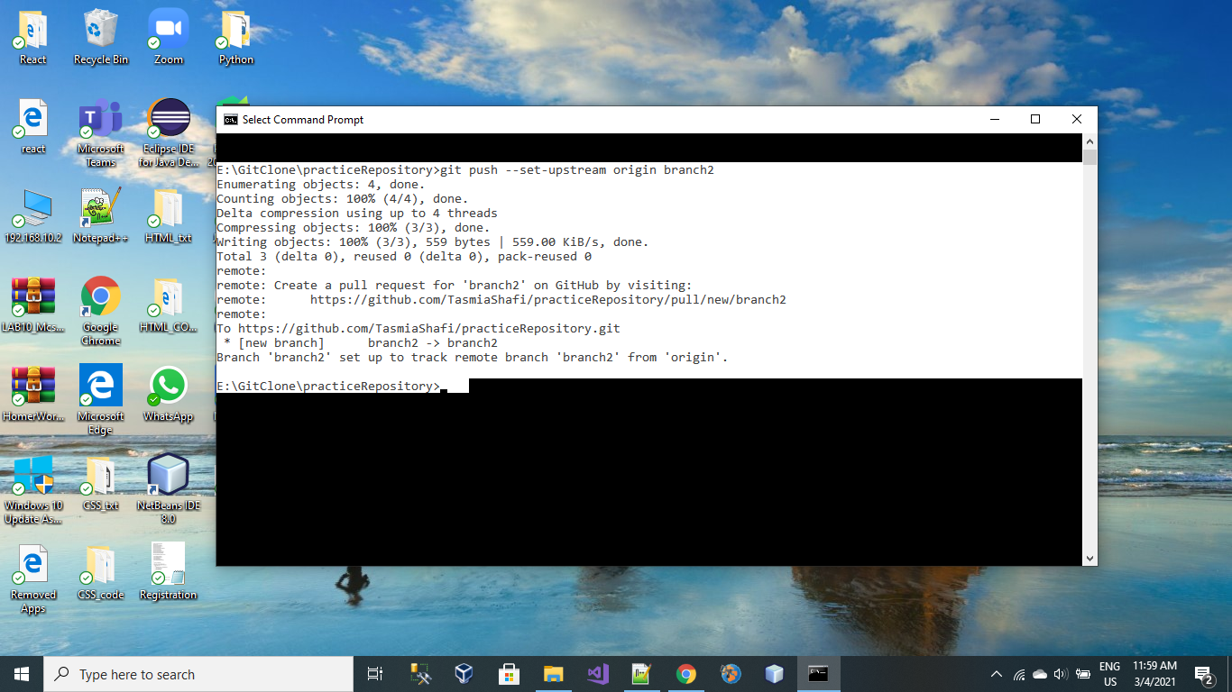

File with name “withoutStyle.html” has been pushed into repository.

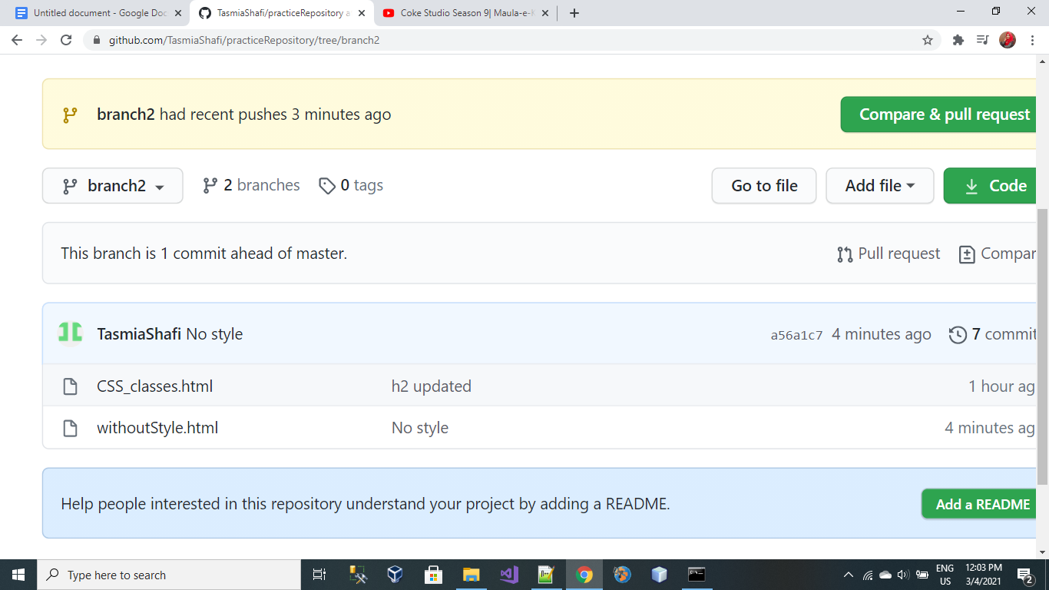

**Merge branches:**

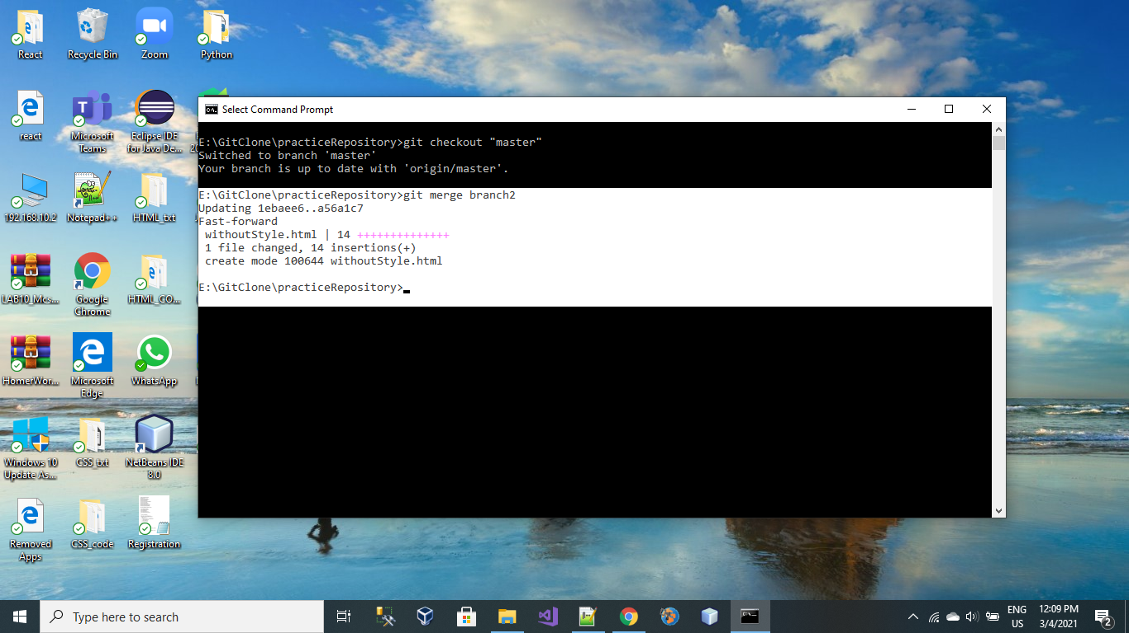

**Branching has been Done**

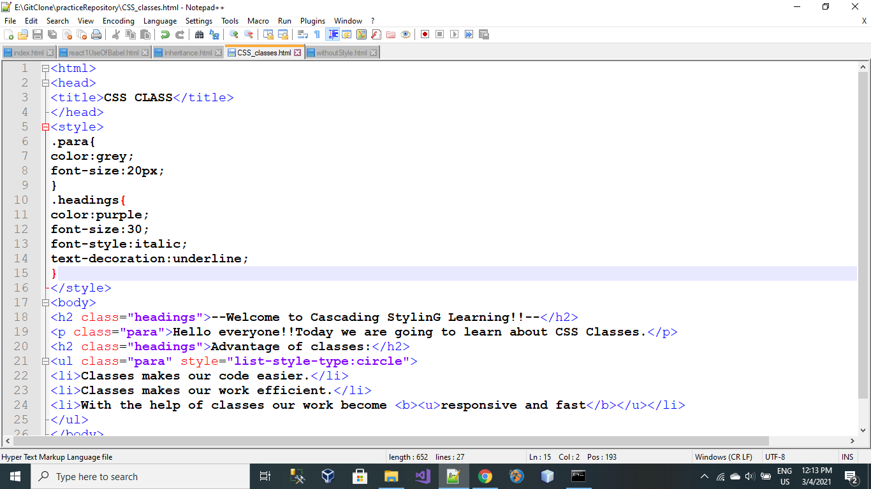

**git Status Command:**

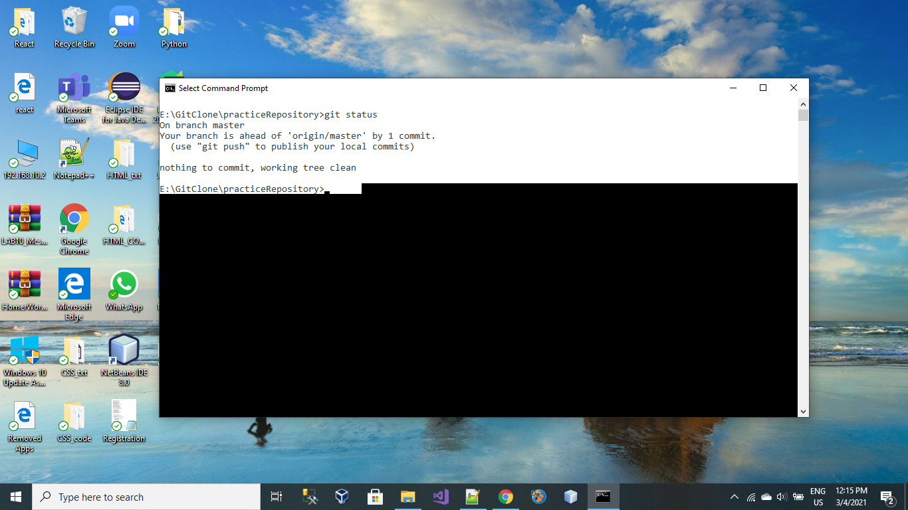

Lecture 4:

Date: 3 March 2021

Introduction to Android IDE

Lecture 5:

Date: 8 March 2021

Android Layout

Lecture 6:

Date: 10 March

Activities And Intents:

Create the project as we created in Android.

Add new Activity in your project as shown in picture.

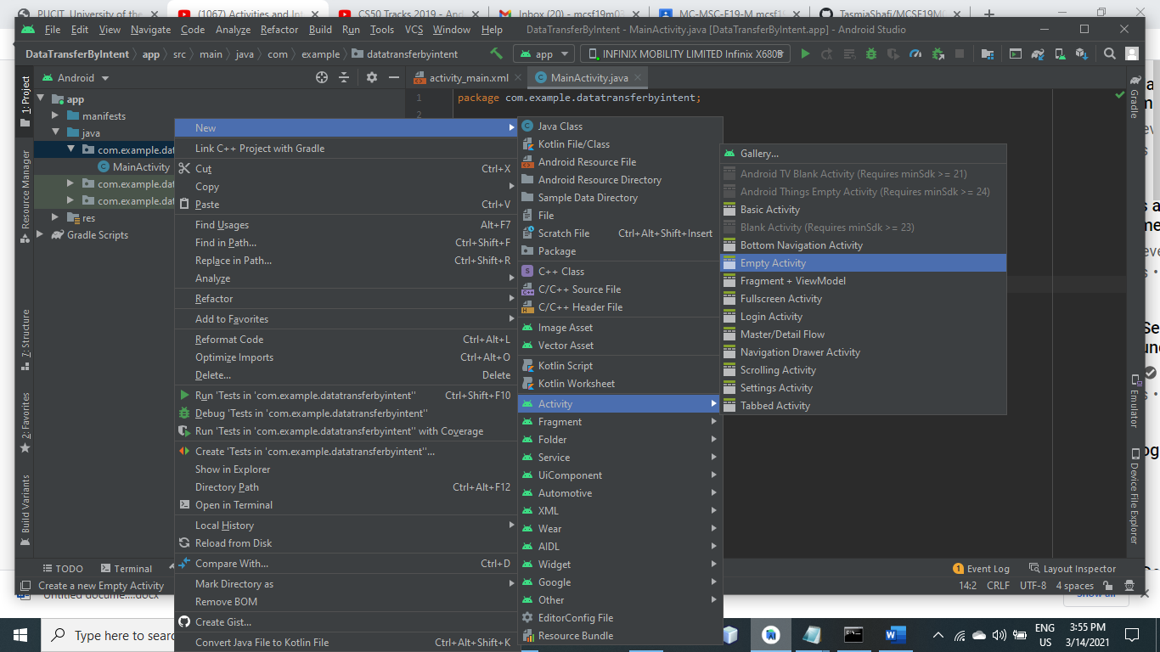

Type name of Activity.

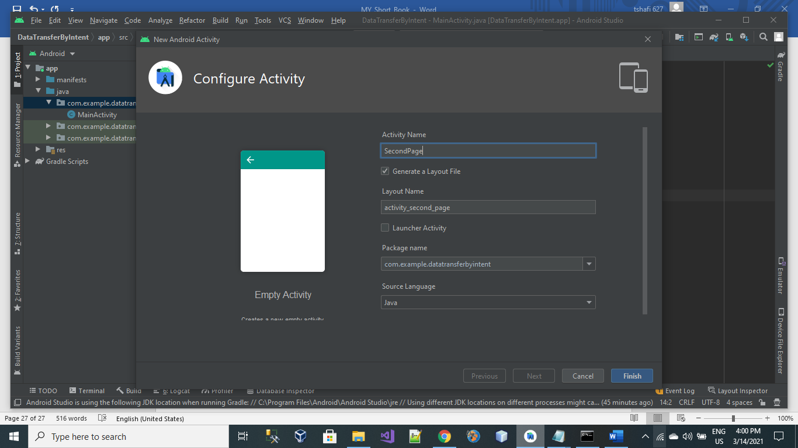

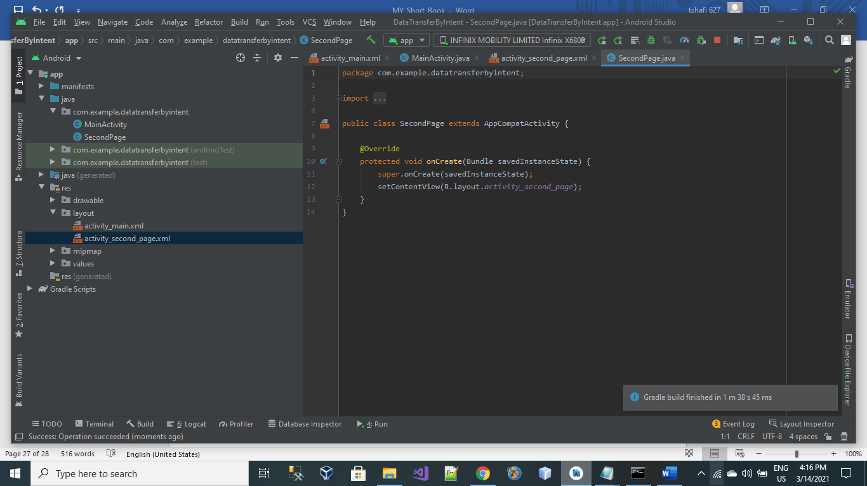

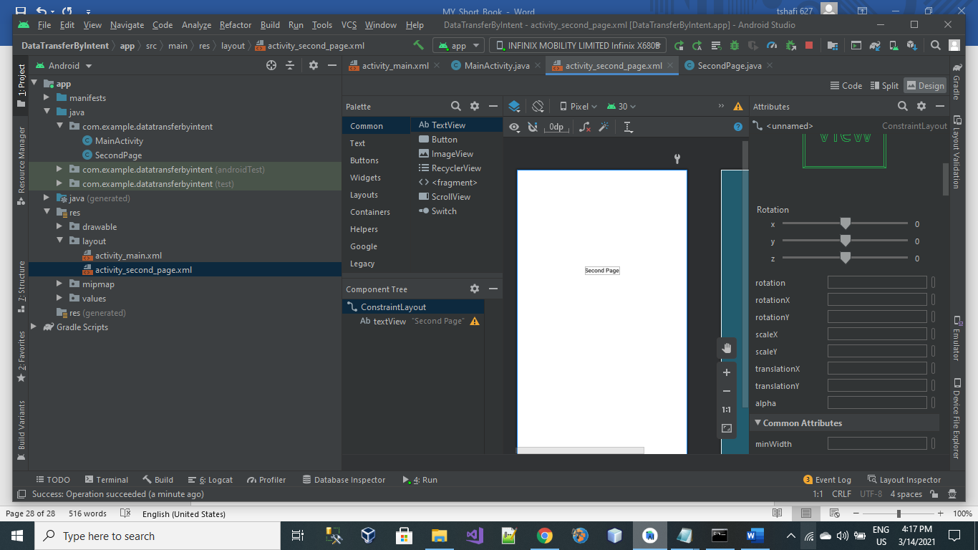

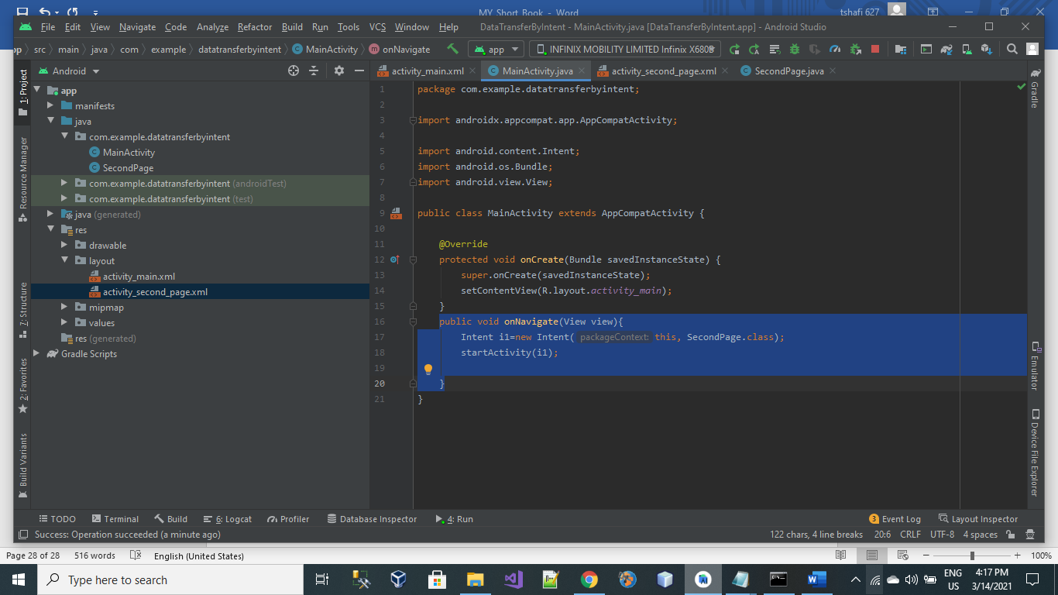

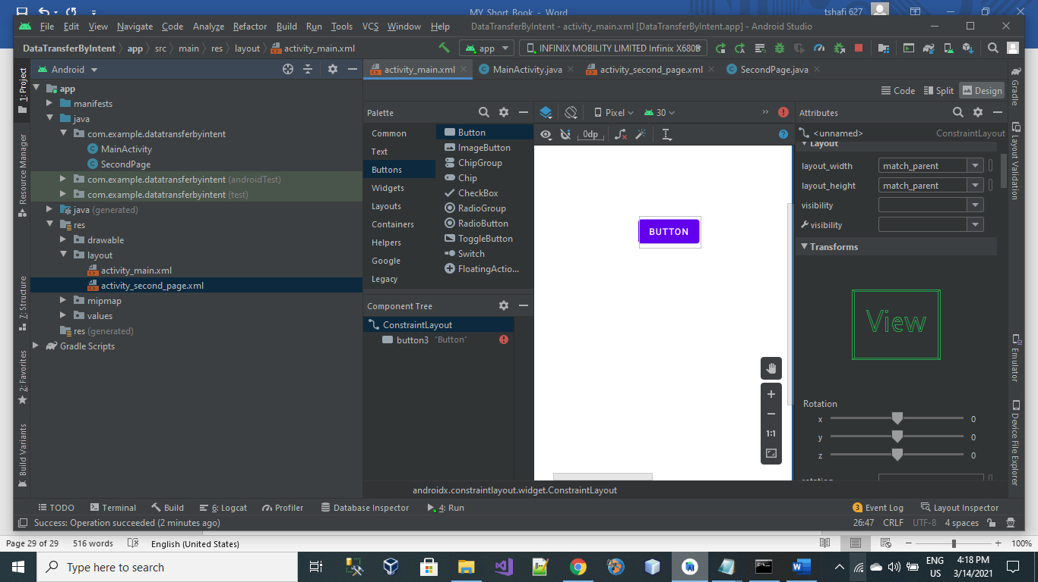

The Following Screen shots are about Login App.

In this App My Main Activity ask about login credentials and render all entered data into second Page.

Lecture 8:

17March 2021

LIFE CYCLE OF ACTIVITIES:

USE CASE 1:

There are 2 activities, activity 1 contains a button. When user press the button it moves towards the activity 2 and the life cycle of activity is shown below.

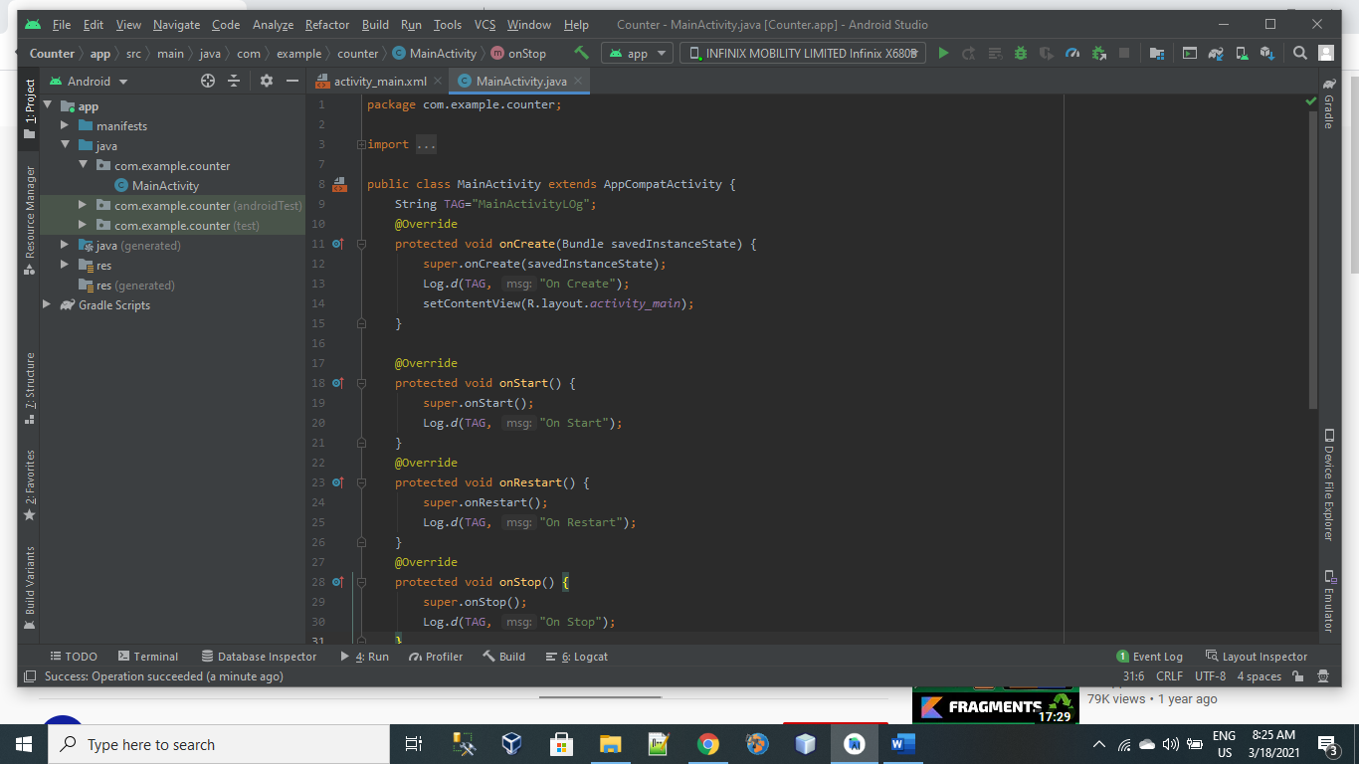

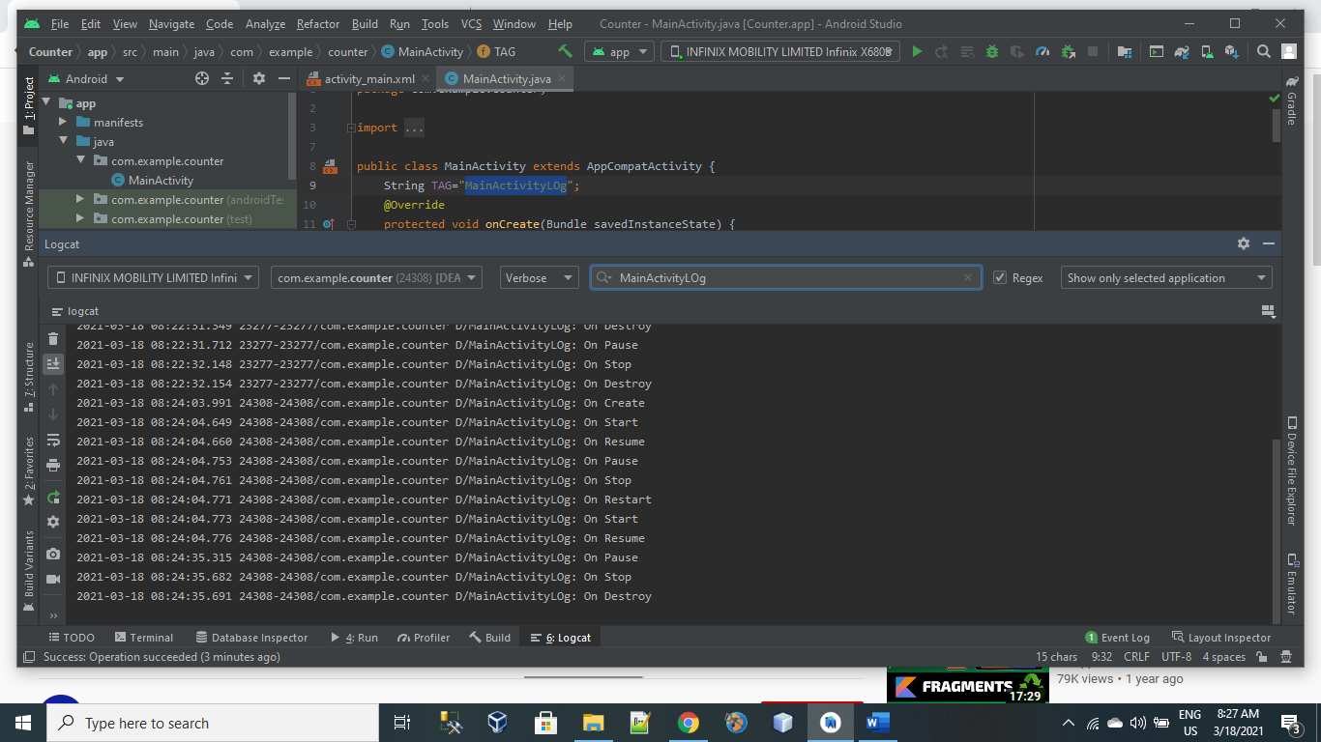

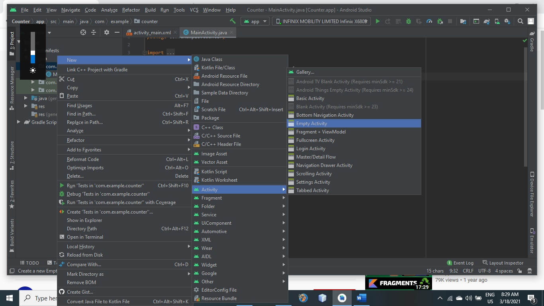

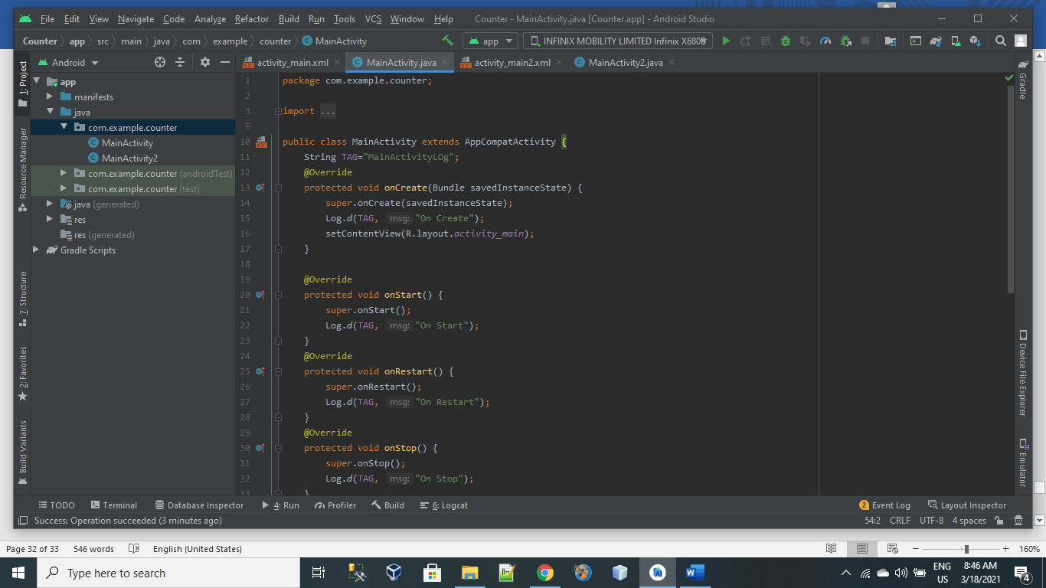

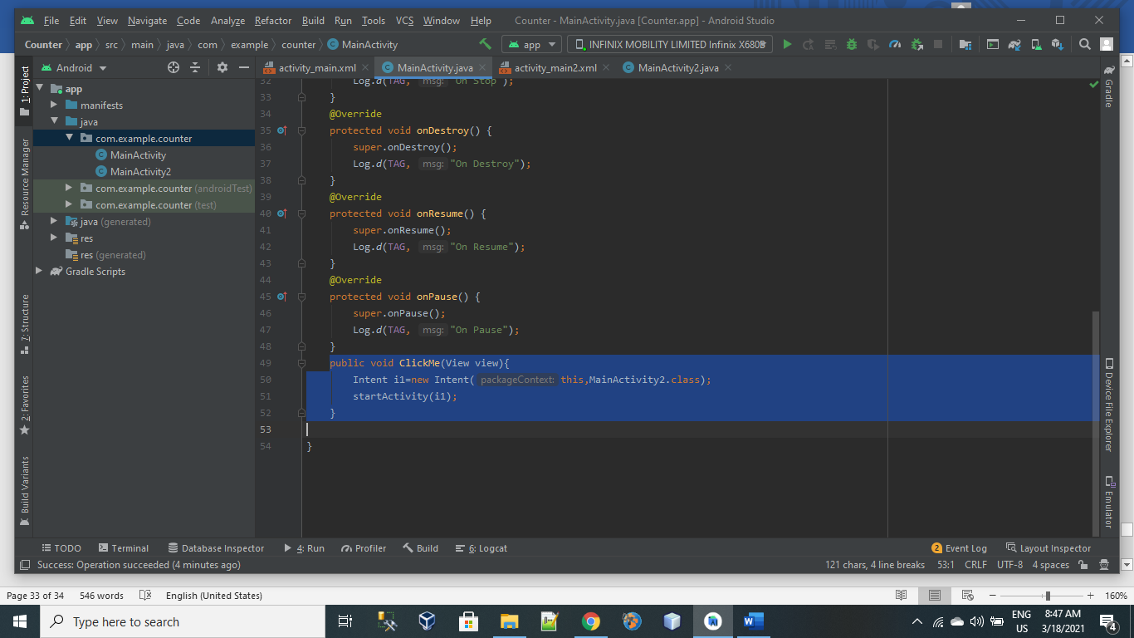

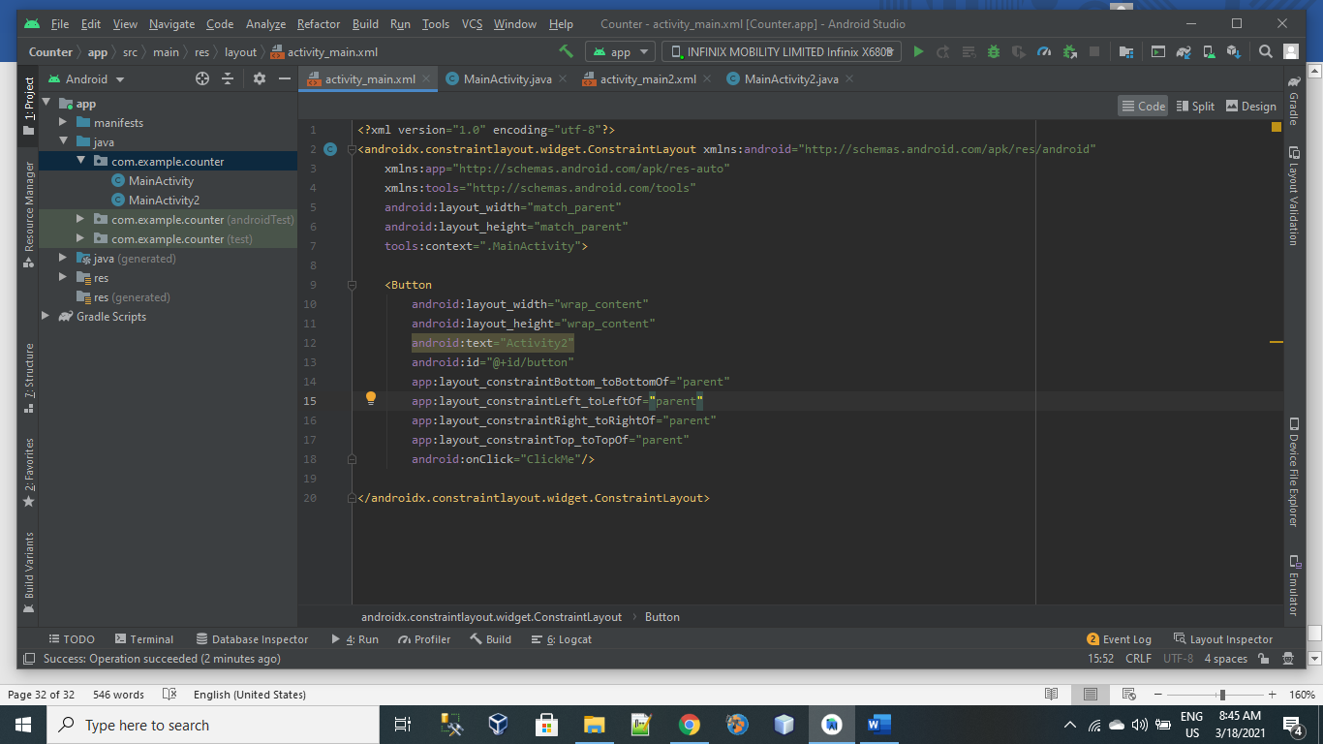

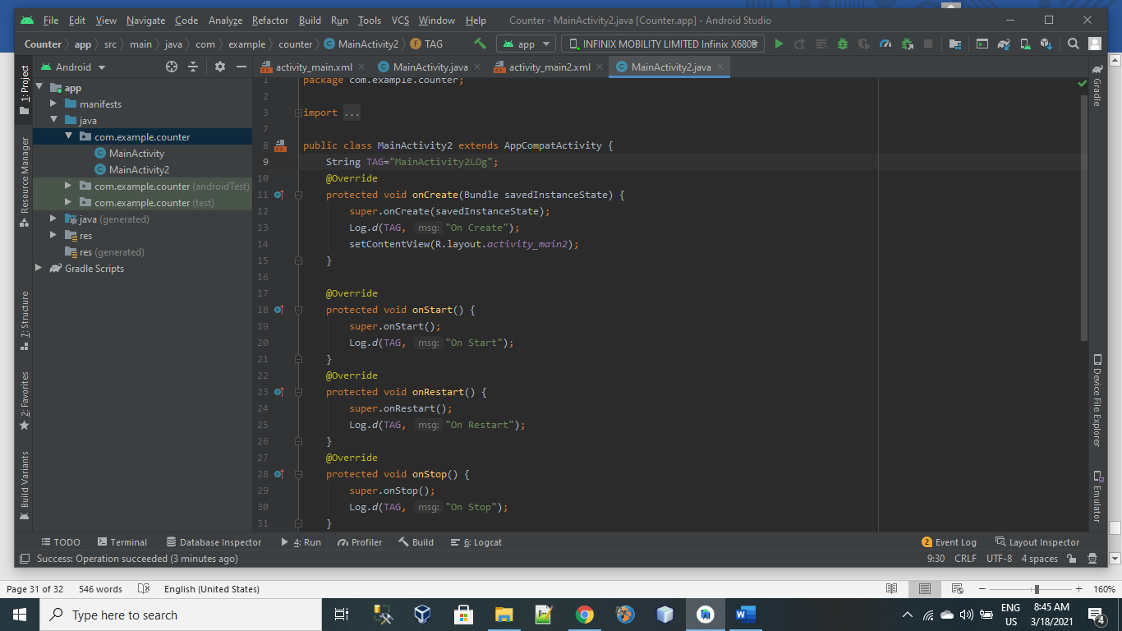

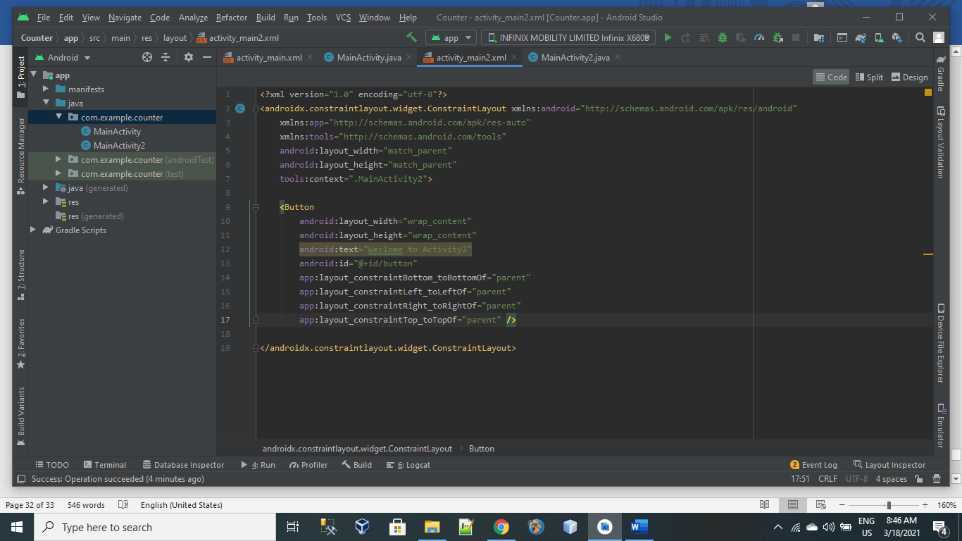

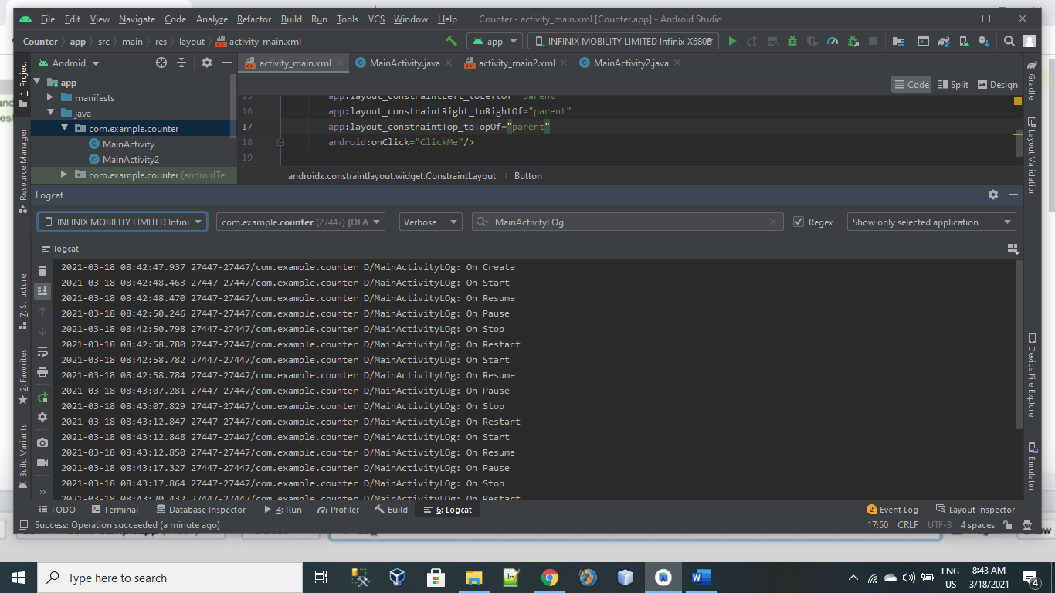

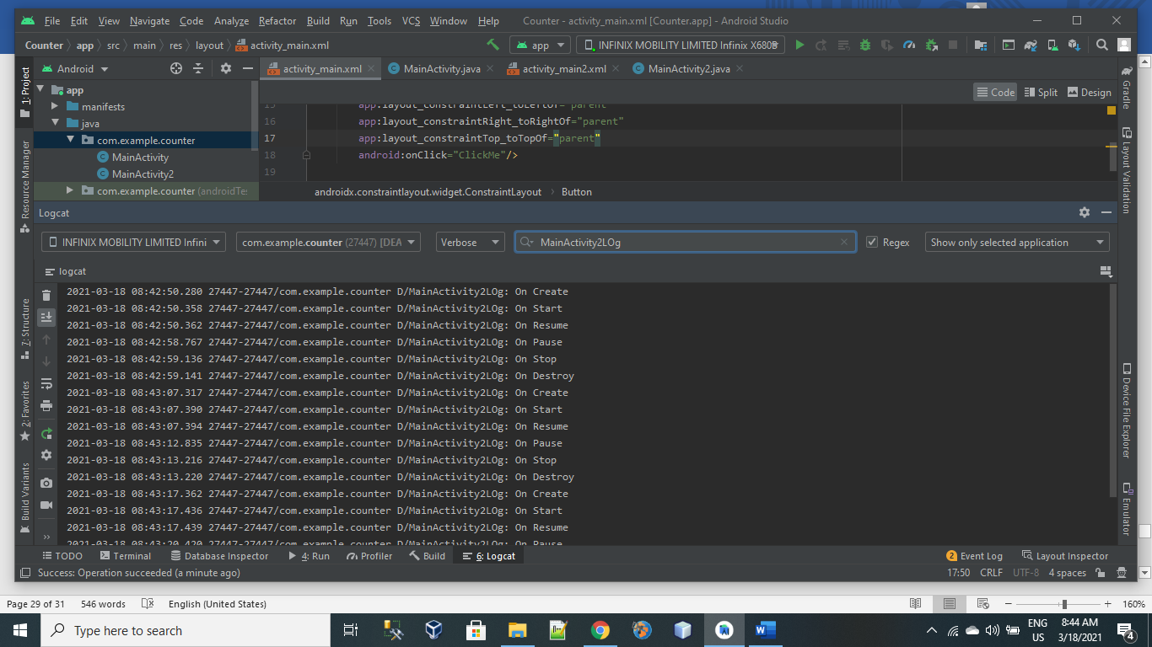

USE CASE 2:

Press lock screen Button.

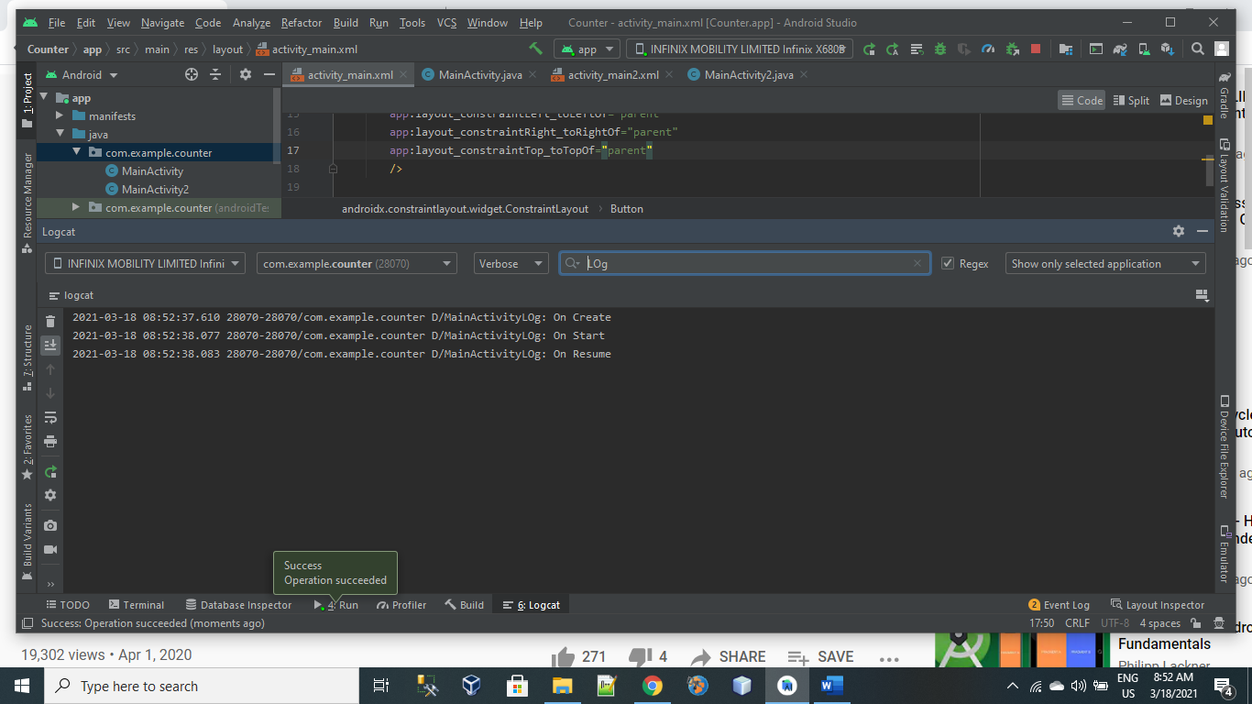

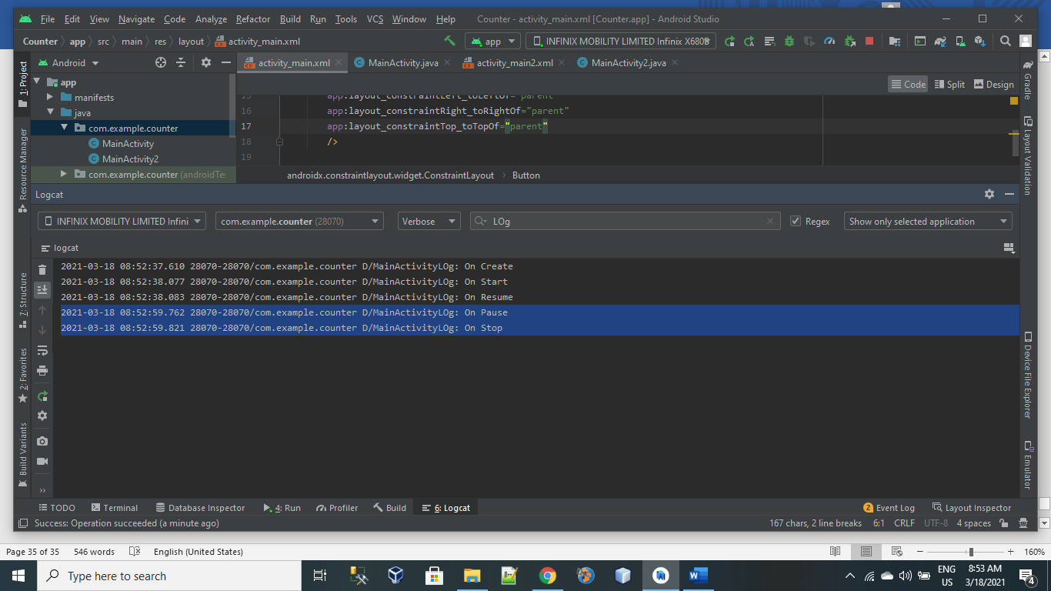

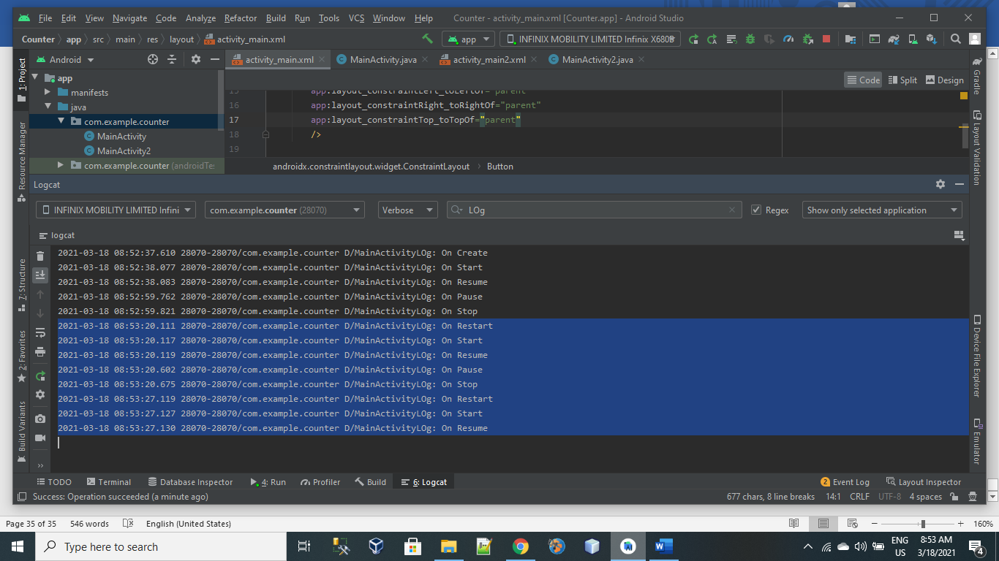

USE CASE 3:

Press Home Button:

On Start():

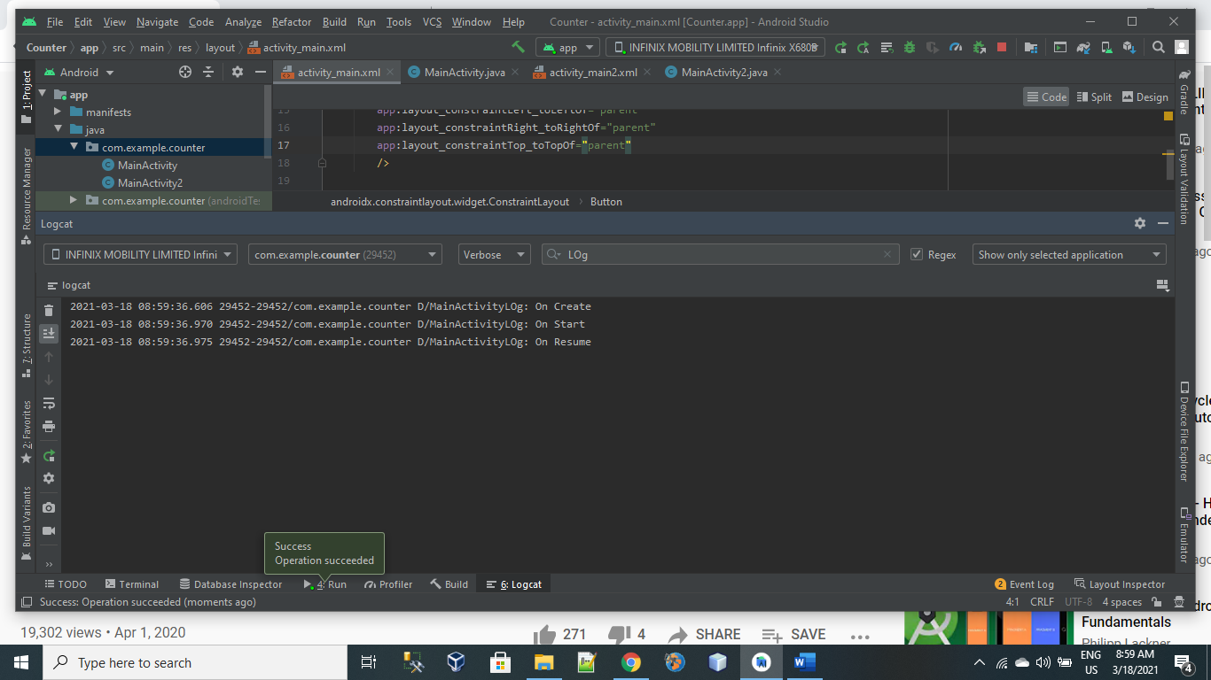

When Home Button Pressed:

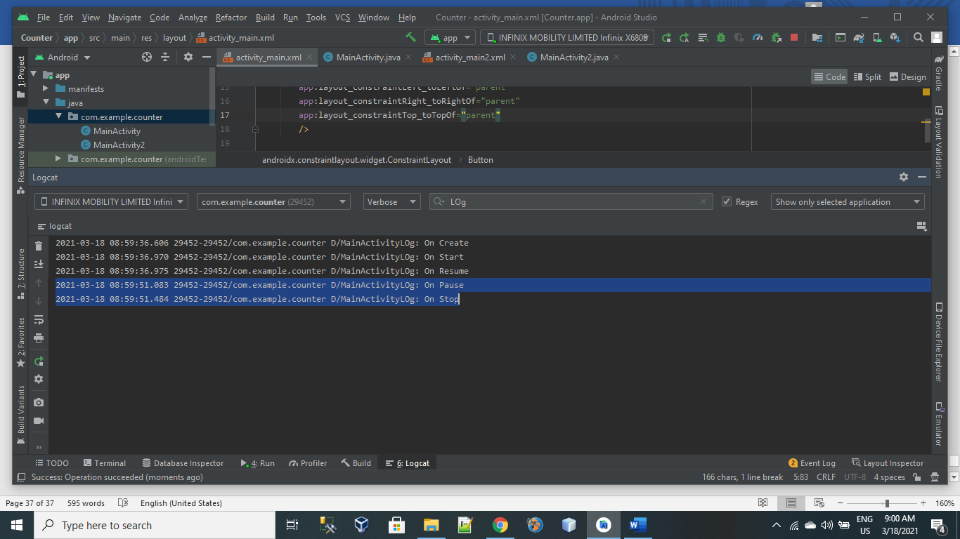

Again Start The App:

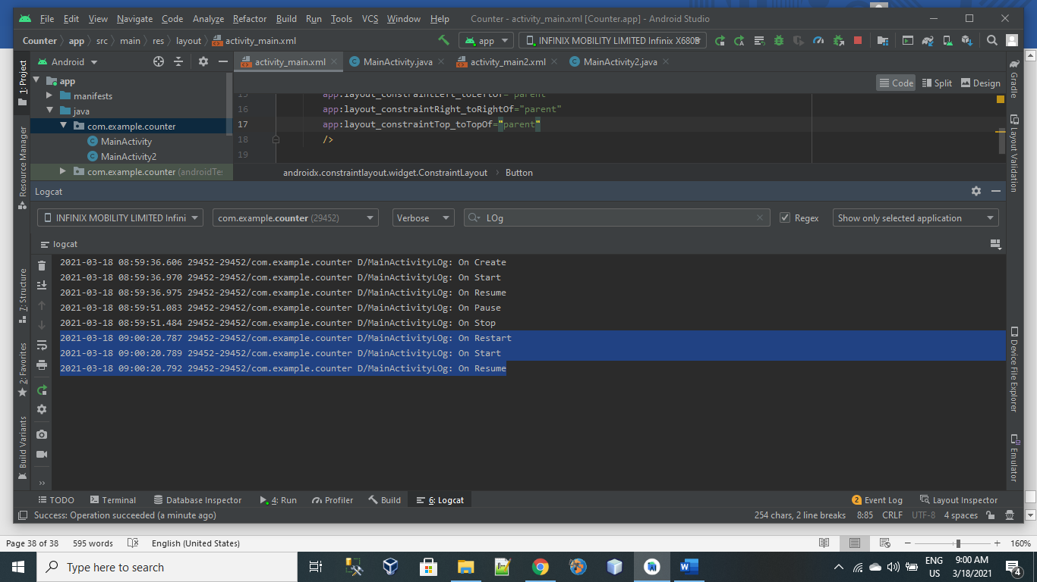

USE CASE 4:

KILL THE APP:

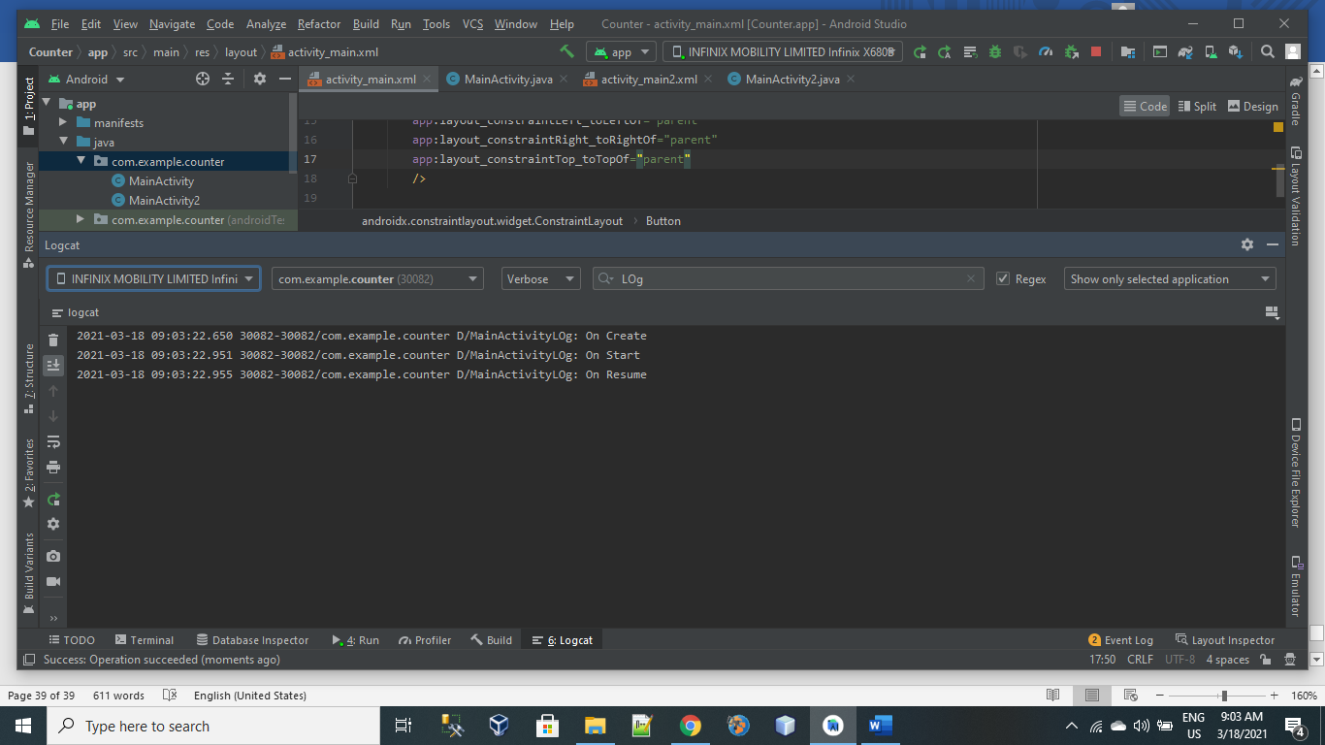

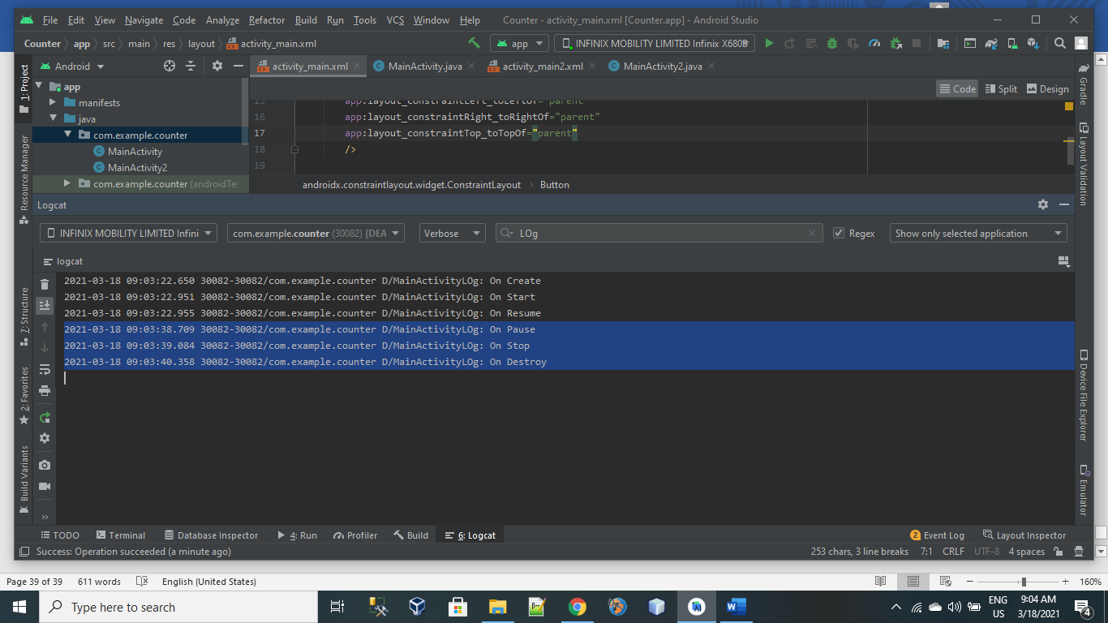

USE CASE 5:

ASK PERMISSION:  
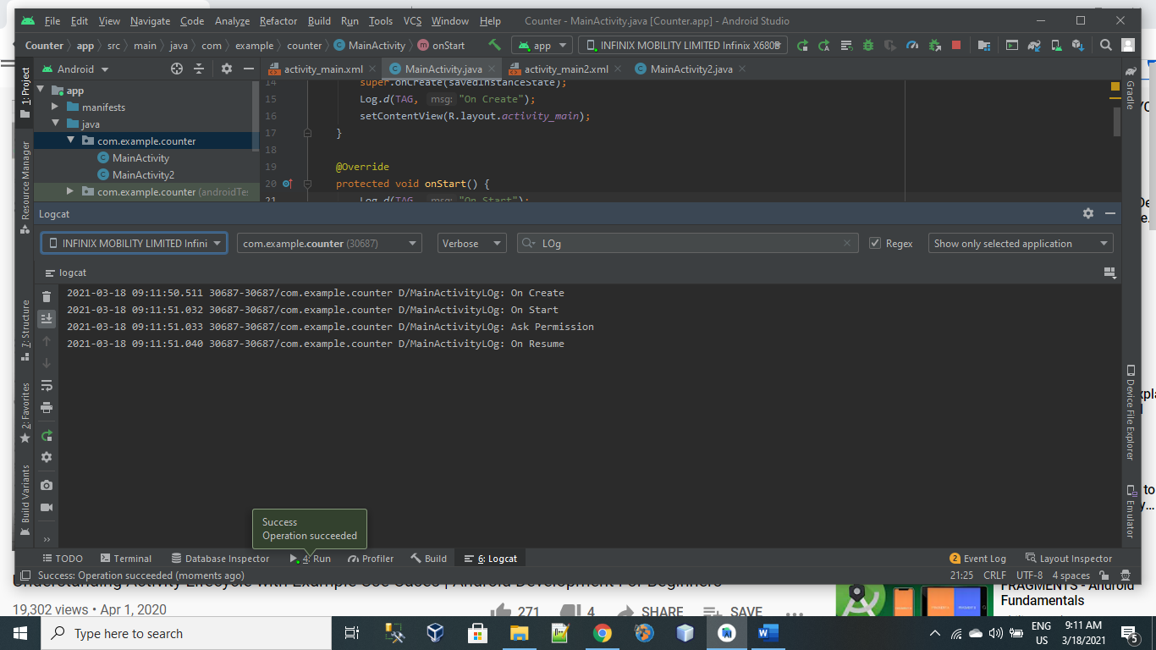

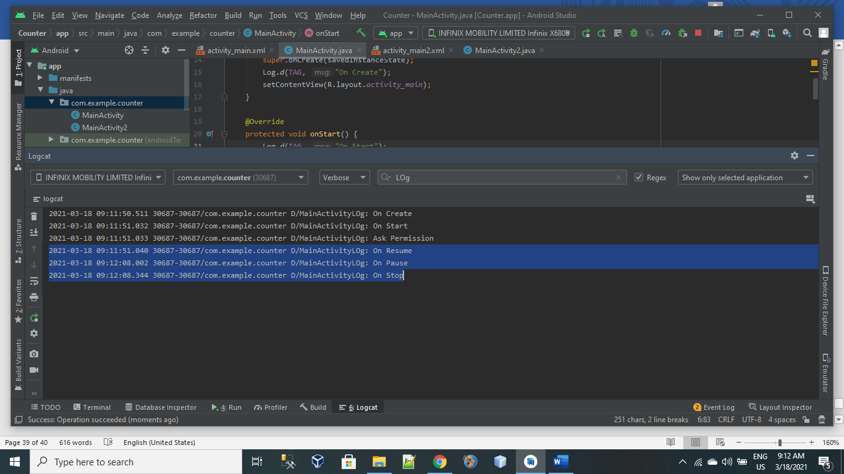

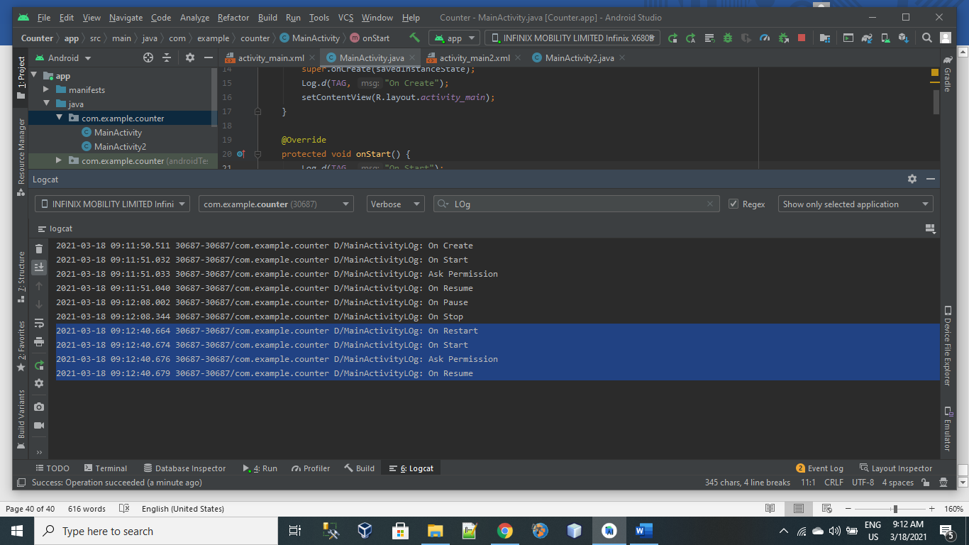

Lecture 8:

List View:

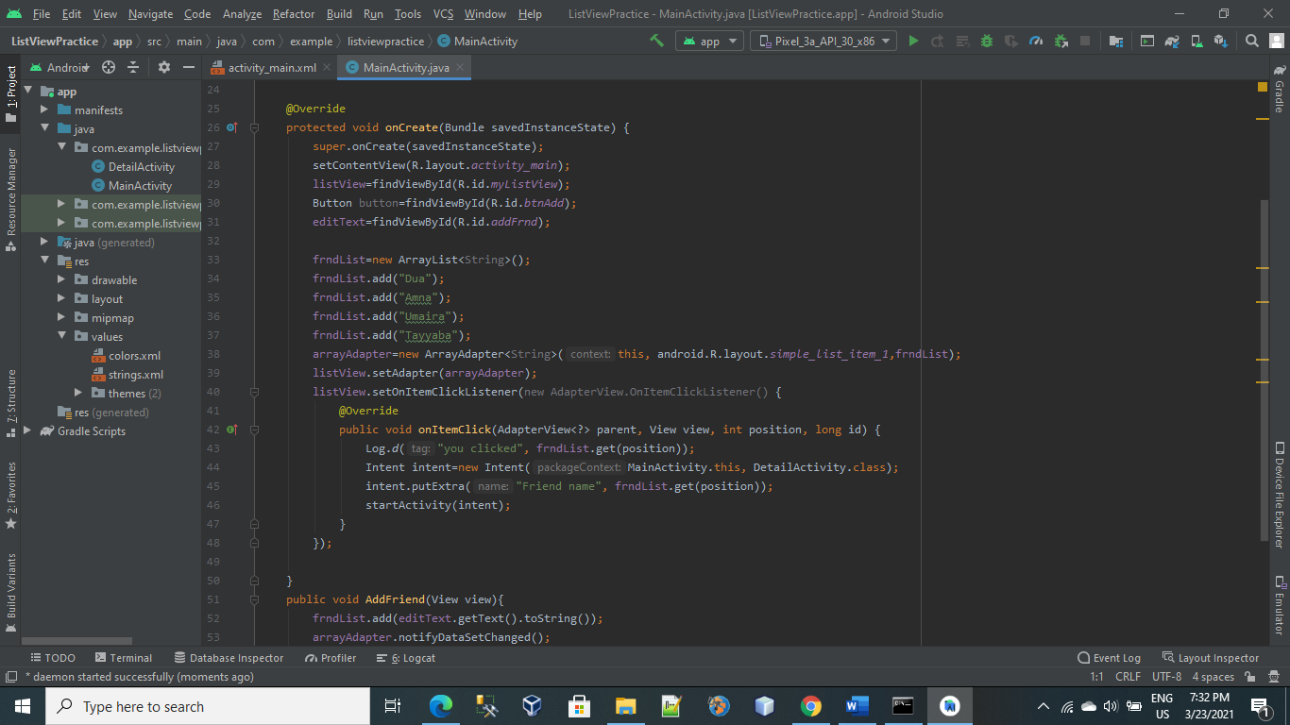

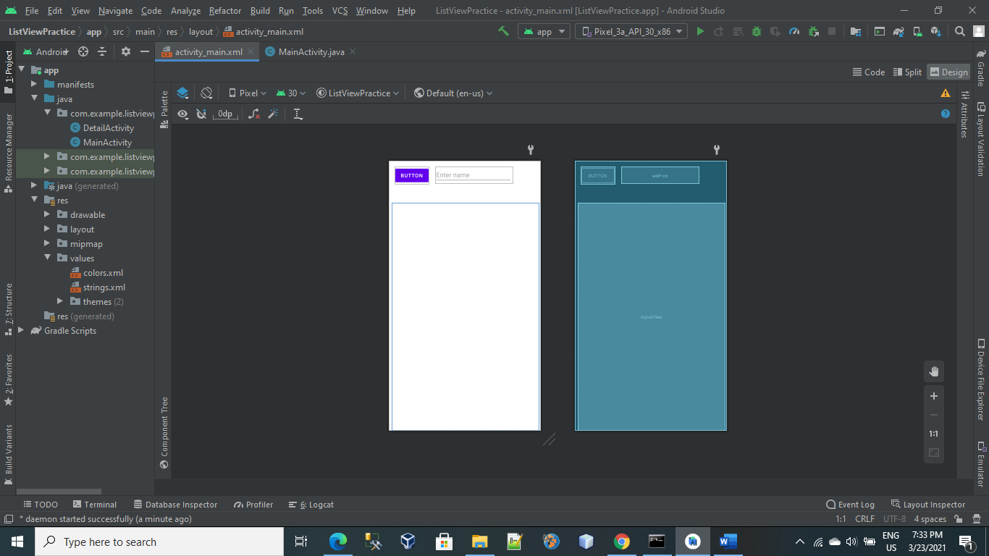

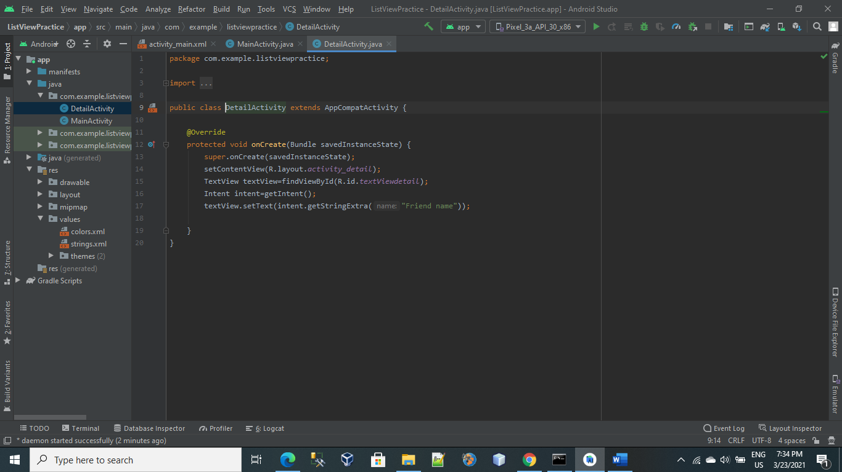

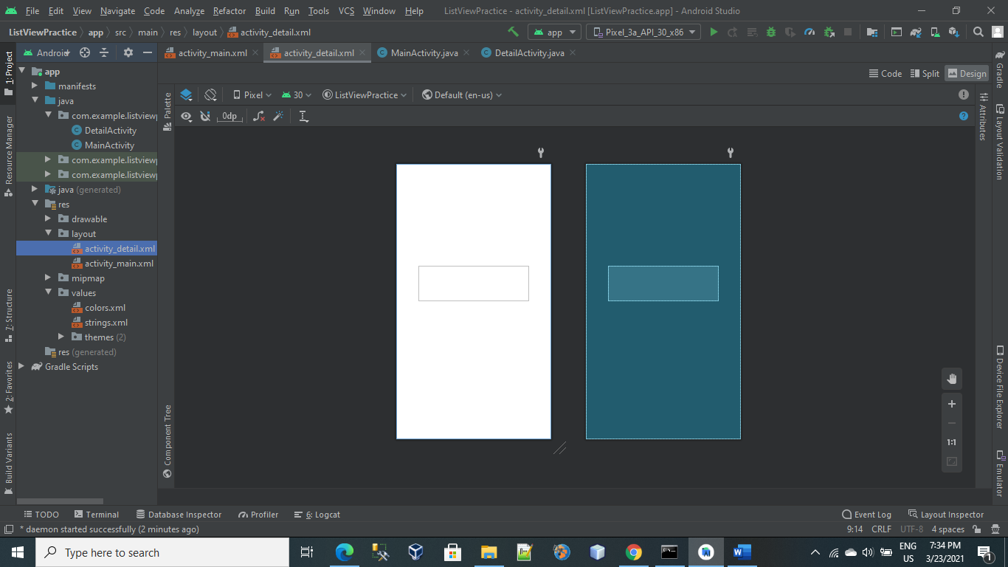

Lecture 9:

SeekBar:

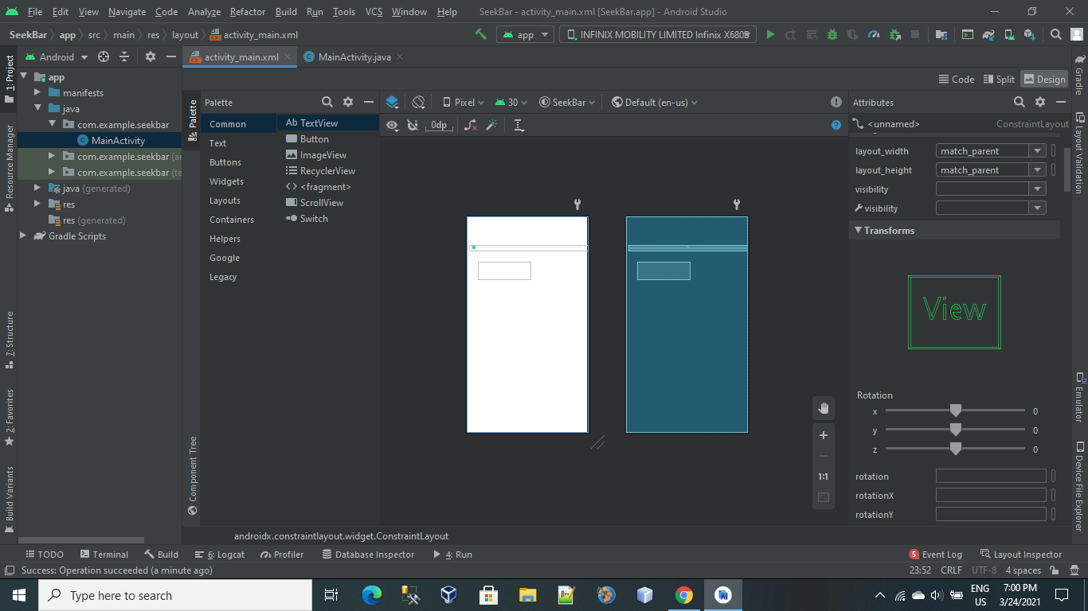

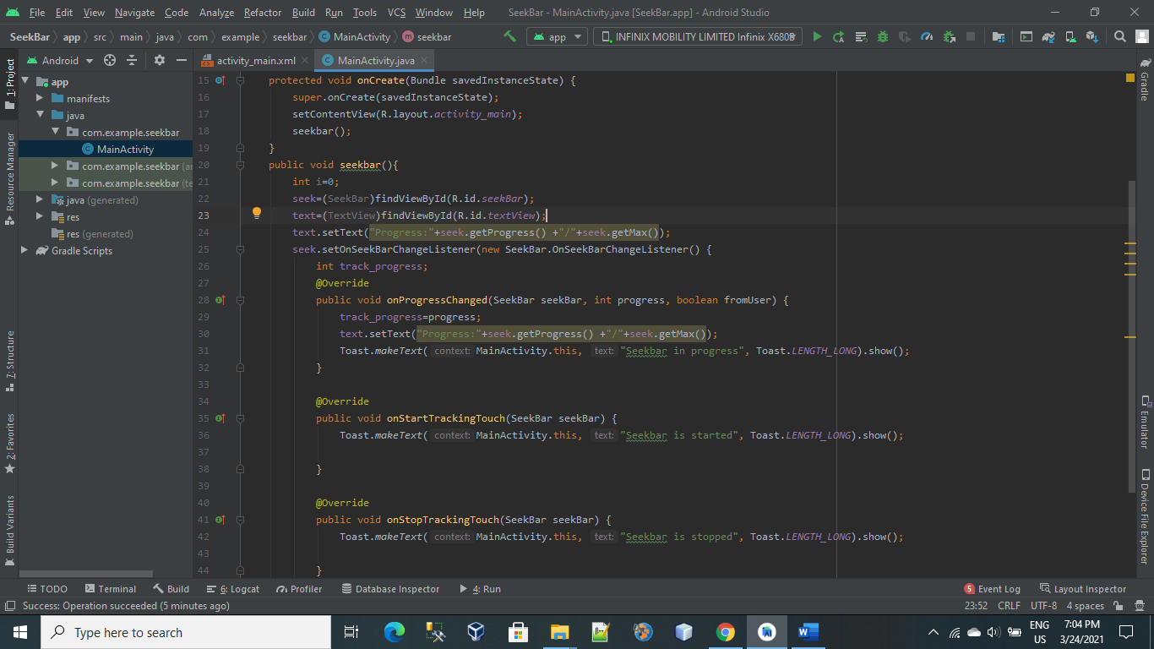

Lec no 13:

Recyclerview Practice:

Adding Dependencies:

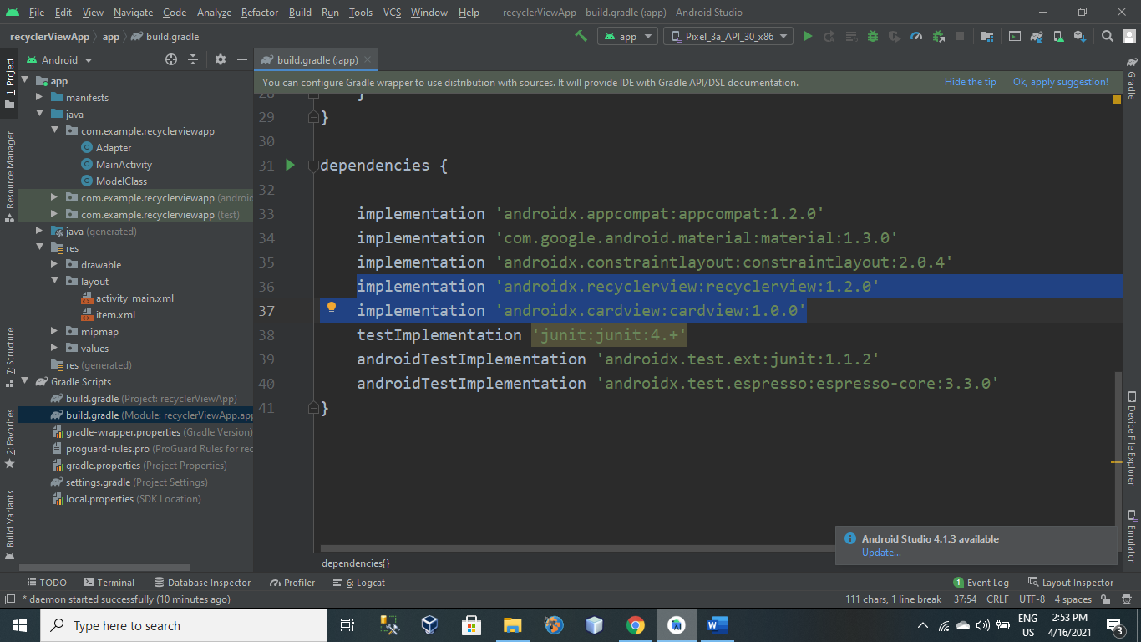

Activity_main.xml:

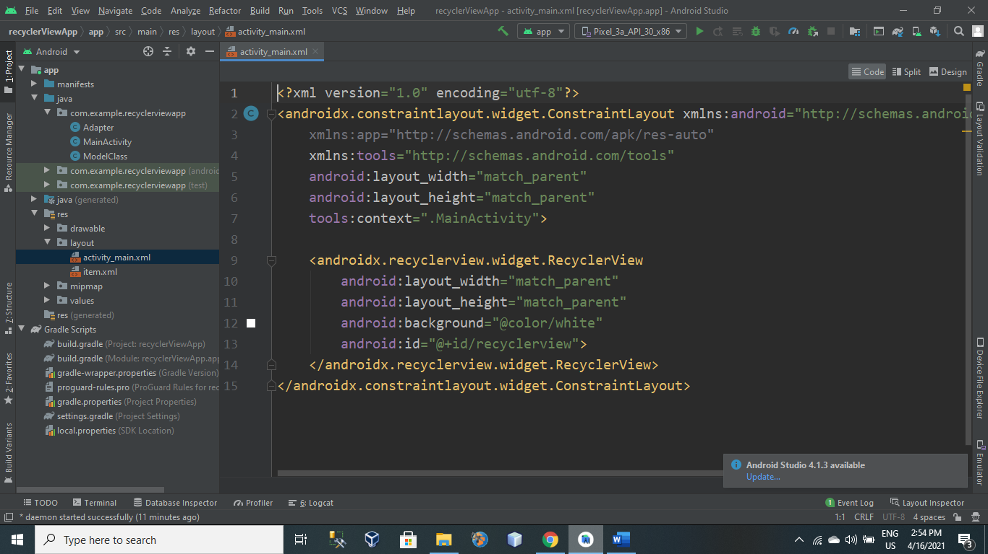

Item.xml:

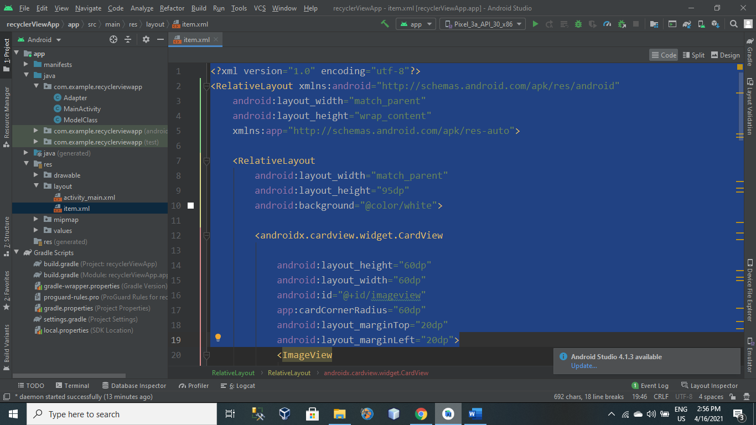

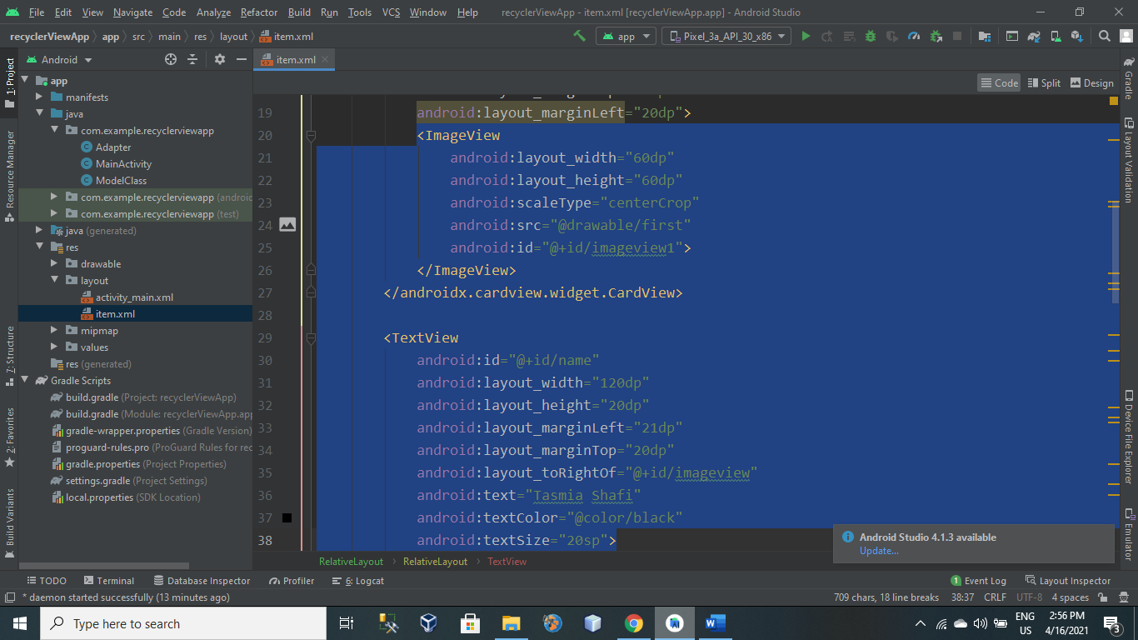

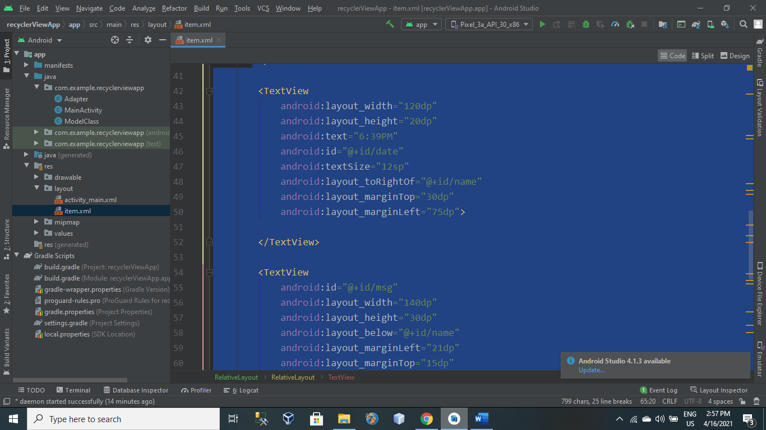

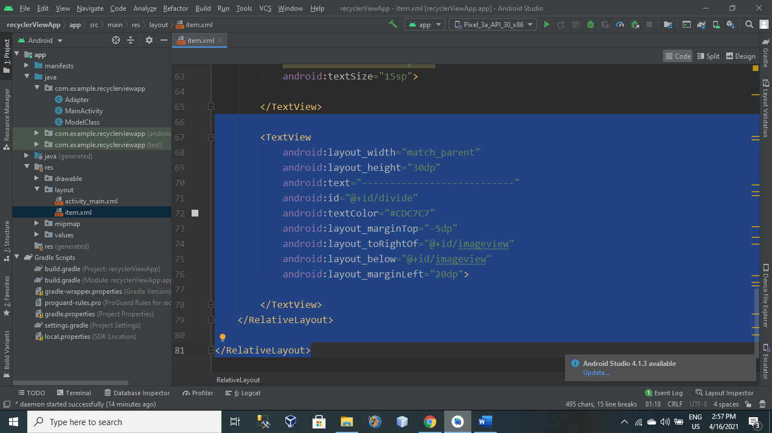

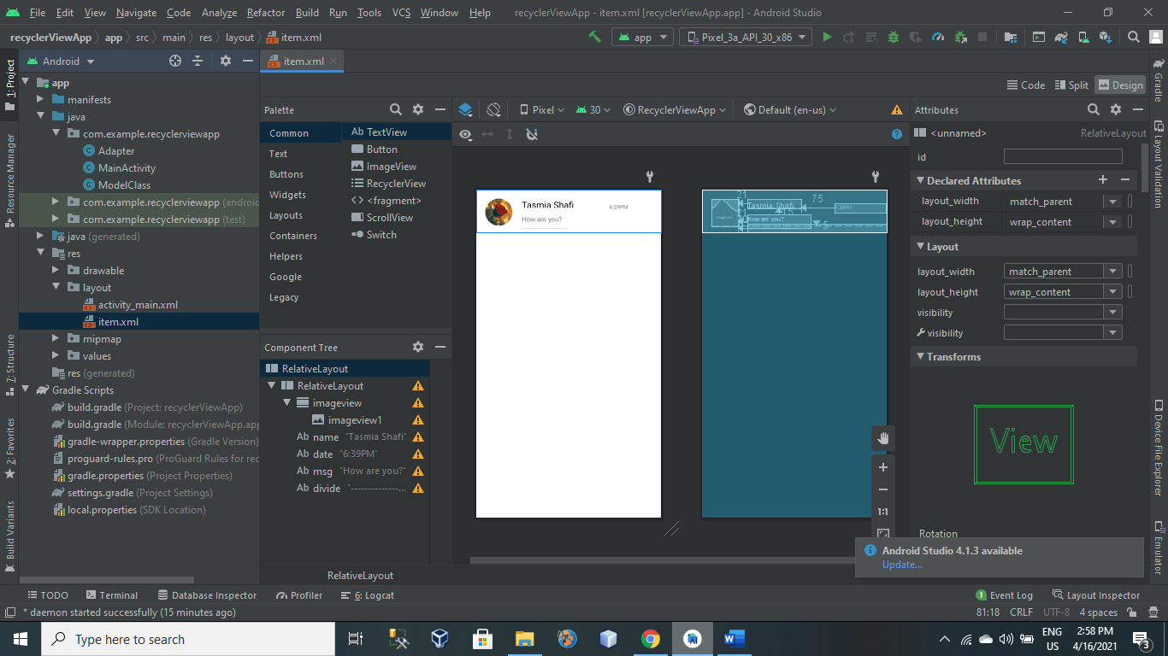

ModelClass.java

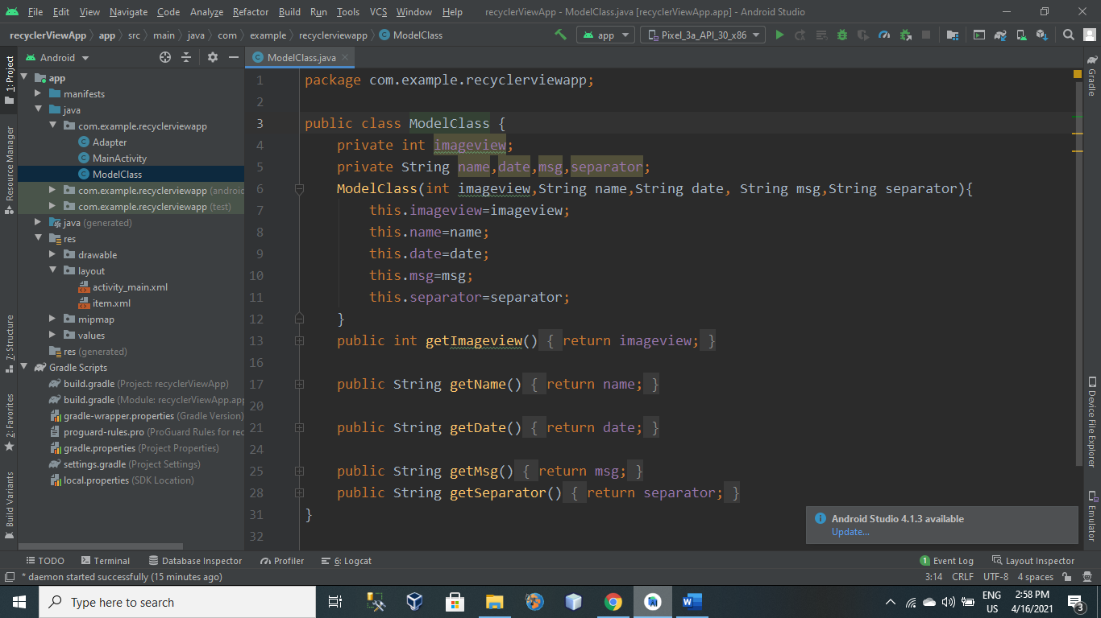

Adapter.java

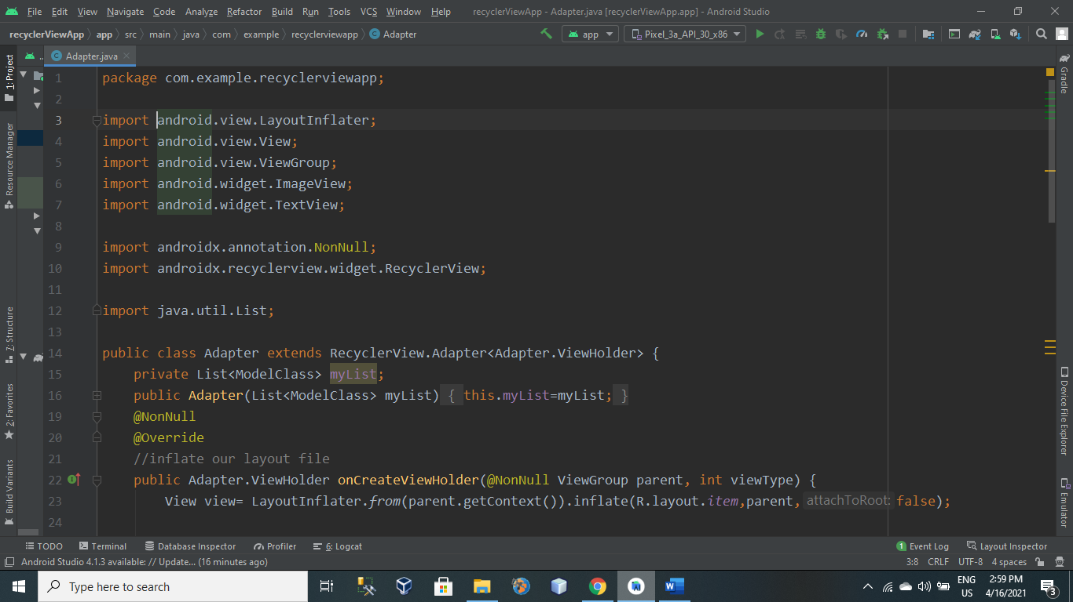

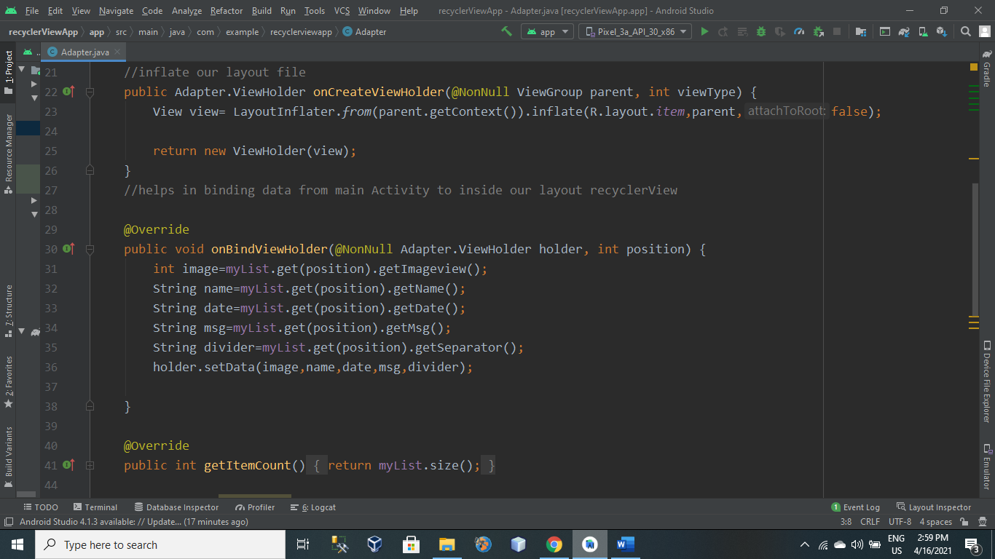

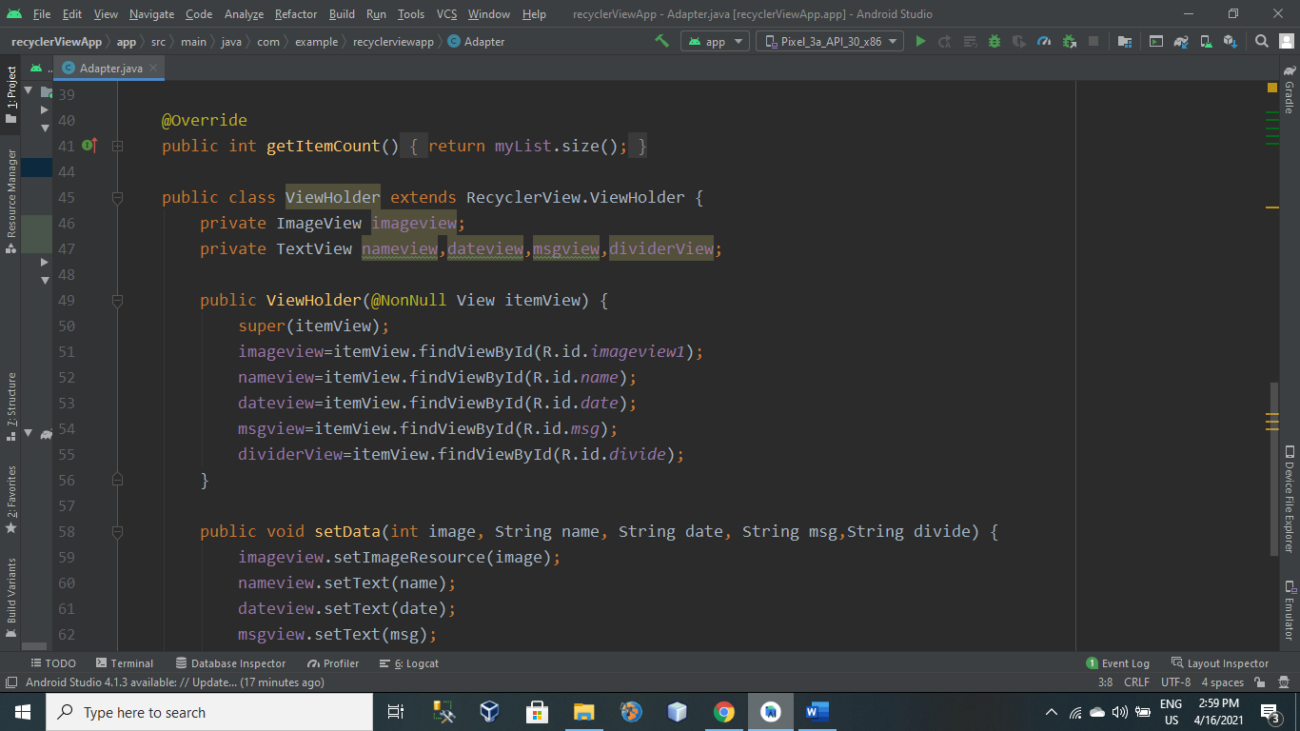

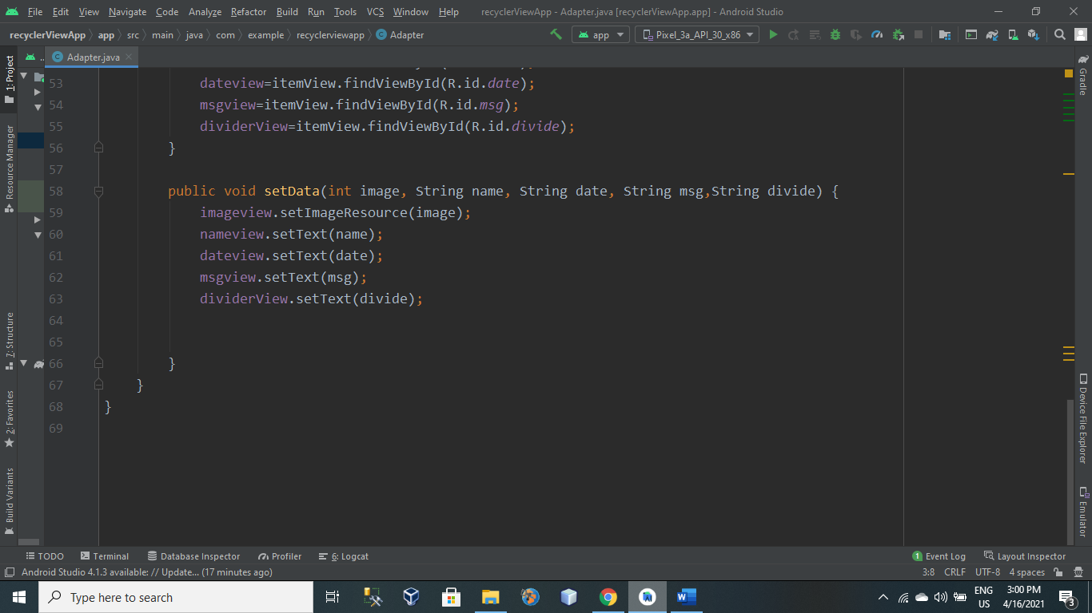

MainActivity.java

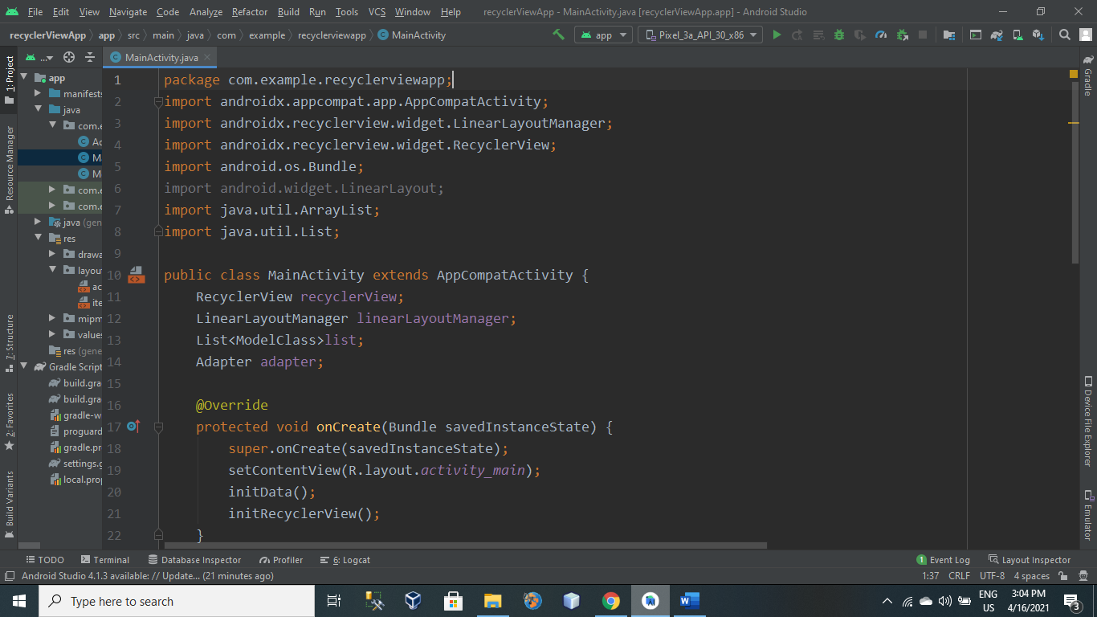

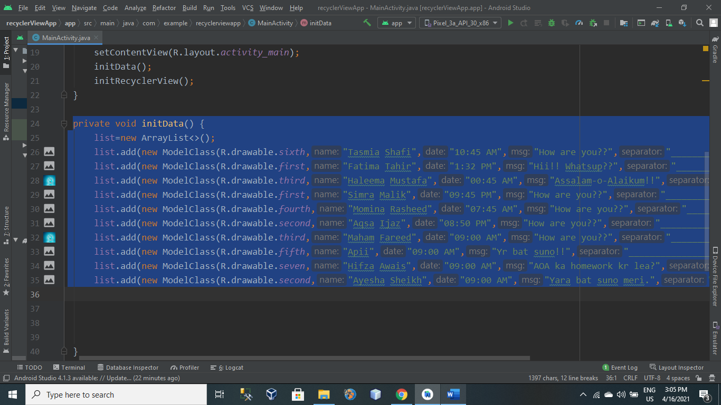

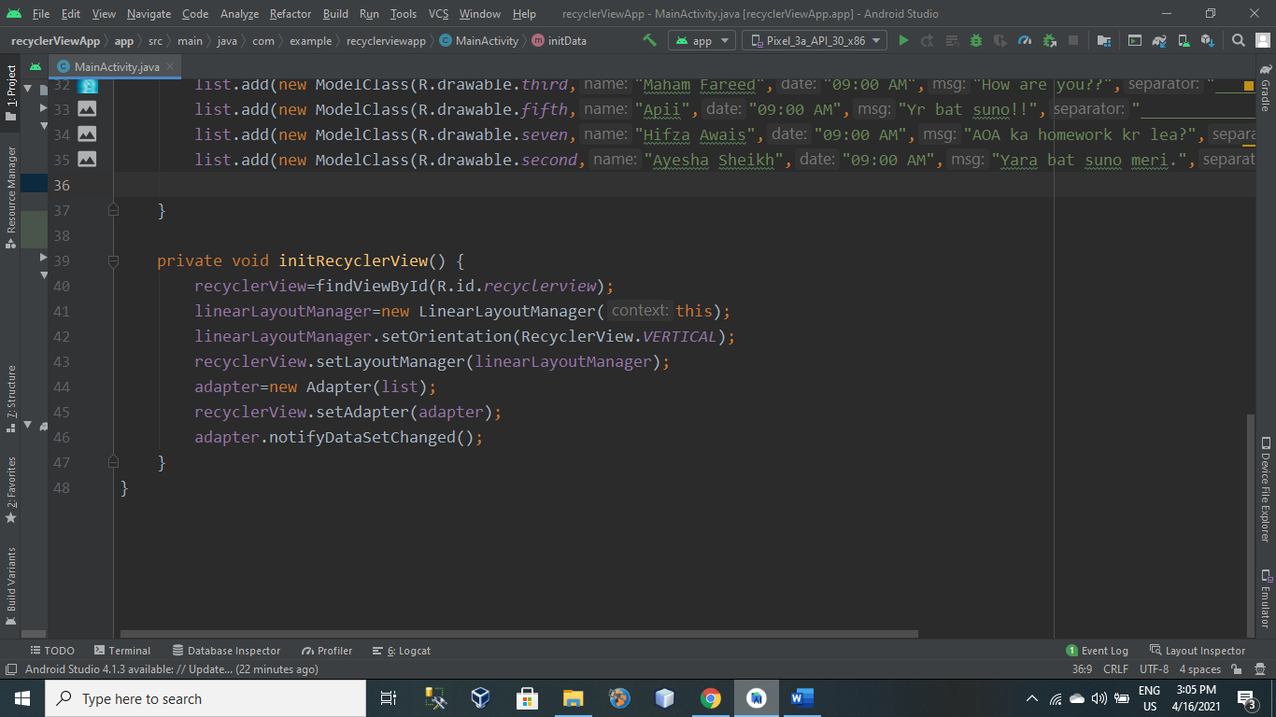

Output:

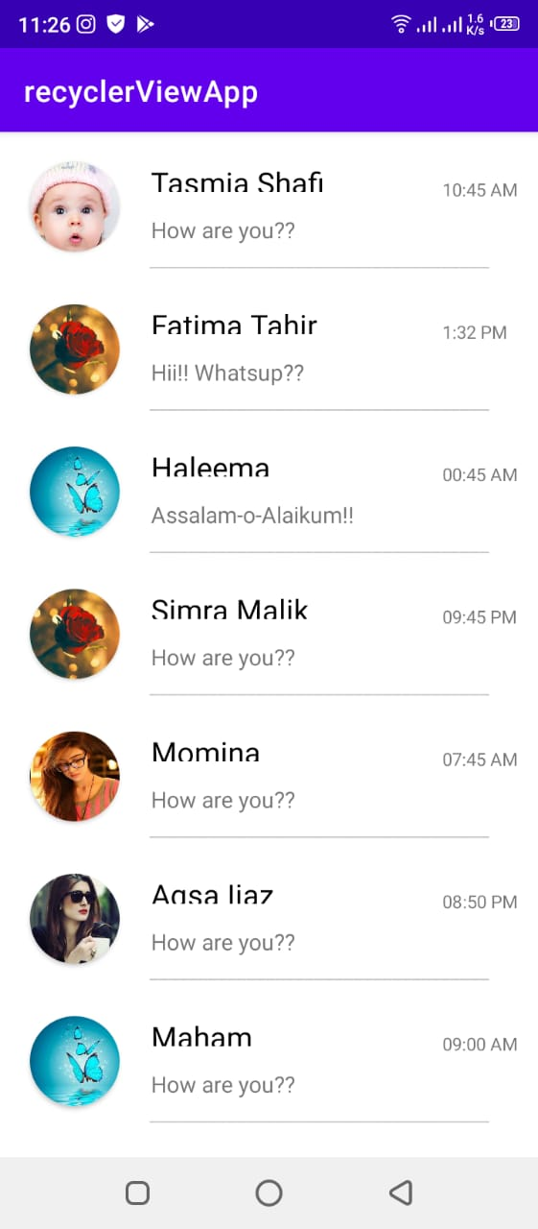

Fragments:

1st activity which contains 3 buttons and 1 linear layout in which fragment is shows.

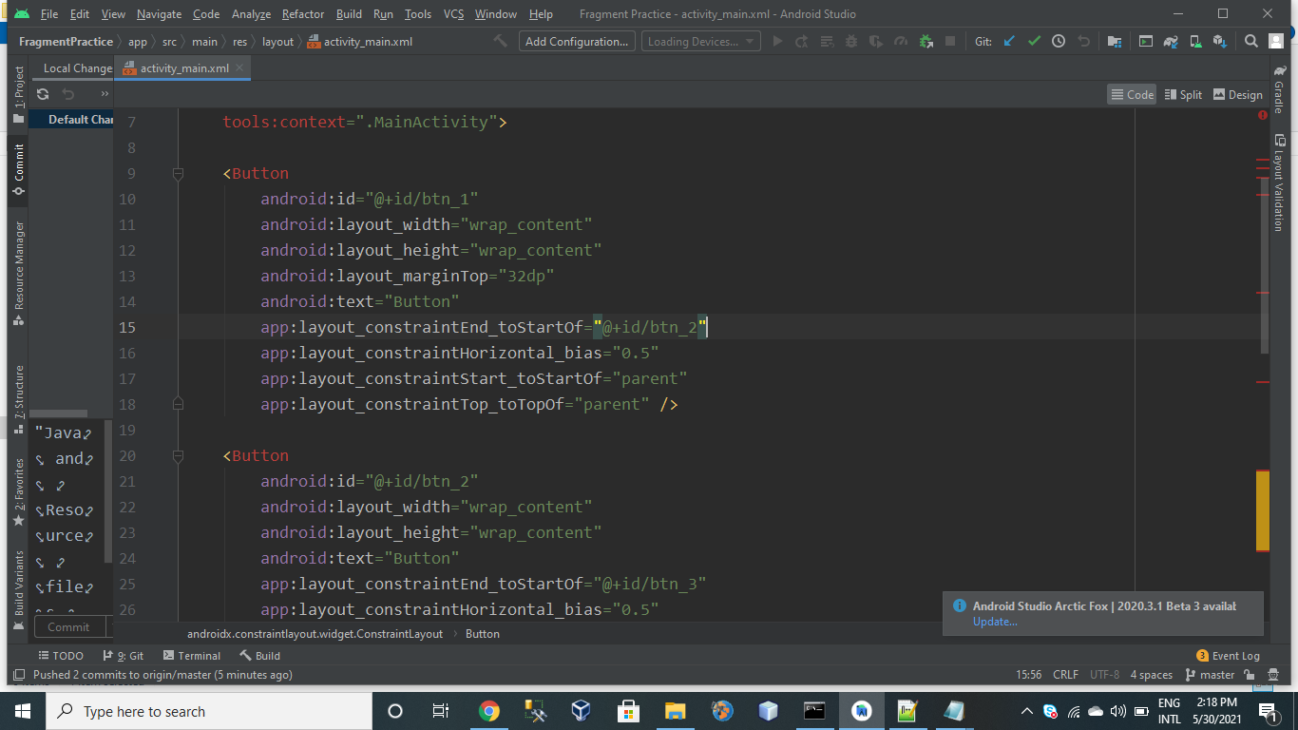

Activity2.xml

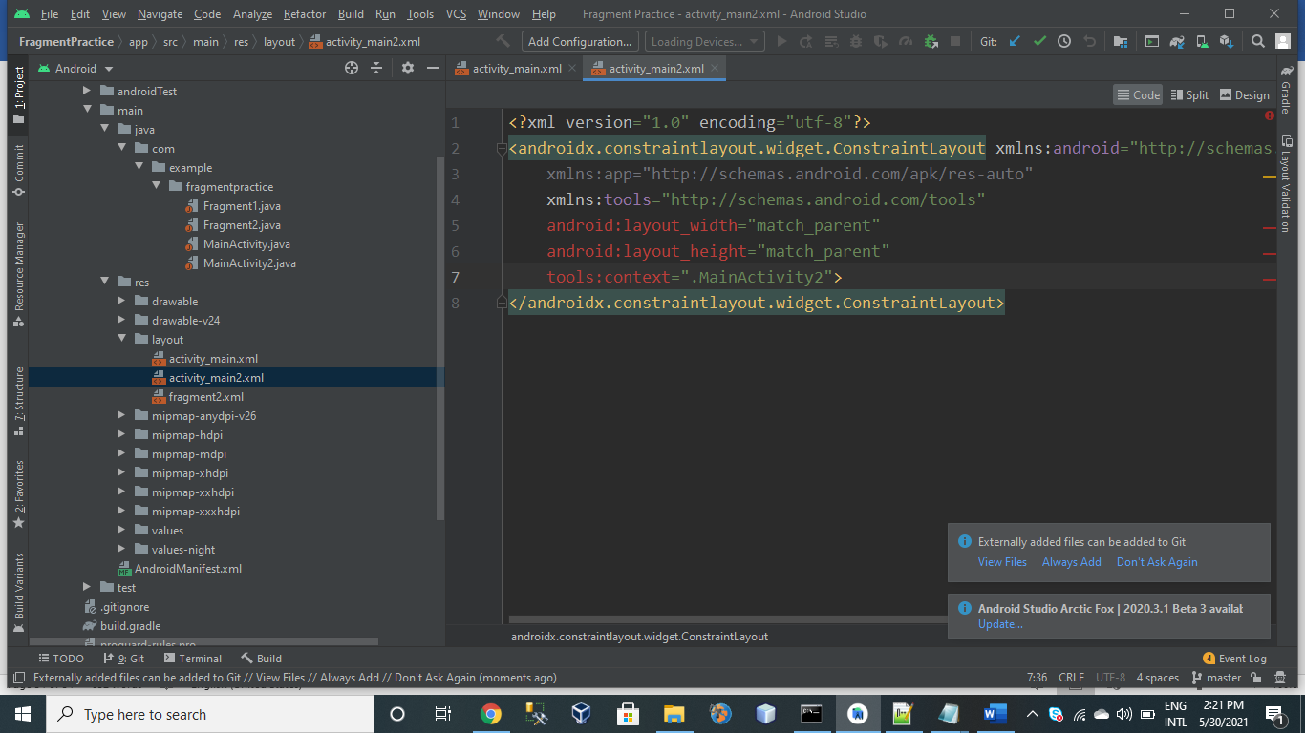

Fragement 2.xml

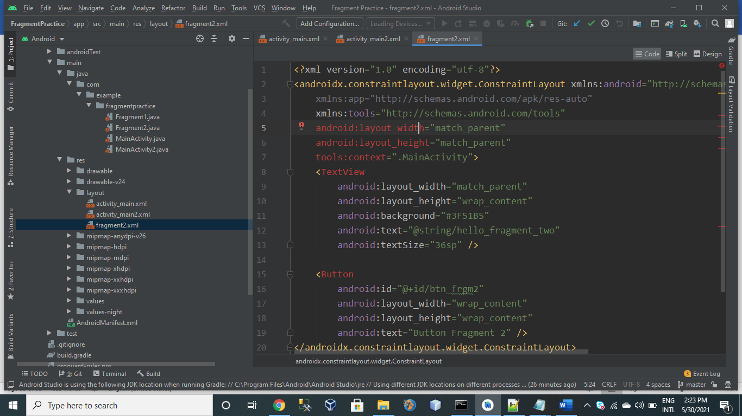

Fragment1.java

